Figure 6
Connections over 200 kbps in at Least One Direction 2017-2021
(in thousands)

 | 2017 | 2018 |  | 2019 |  | 2020 |  | 2021
Technology | Dec | Jun | Dec | Jun | Dec | Jun | Dec | Jun | Dec
Total | 420,838 | 428,864 | 451,062 | 459,327 | 466,302 | 480,185 | 490,888 | 500,261 | 510,198
Total Fixed | 108,065 | 109,087 | 110,784 | 112,725 | 114,291 | 118,449 | 121,250 | 123,425 | 125,777
Mobile Wireless | 312,773 | 319,776 | 340,278 | 346,603 | 352,012 | 361,737 | 369,638 | 376,835 | 384,420

Some previously-published data may have been revised. Numbers may not sum to totals due to rounding.
Source: FCC Form 477.

Figure 7
Residential Connections over 200 kbps in at Least One Direction 2017-2021
(in thousands)

 | 2017 | 2018 |  | 2019 |  | 2020 |  | 2021
Technology | Dec | Jun | Dec | Jun | Dec | Jun | Dec | Jun | Dec
Total | 351,966 | 358,867 | 378,286 | 383,605 | 388,344 | 403,212 | 407,652 | 415,260 | 436,576
Total Fixed | 98,845 | 99,758 | 101,348 | 103,118 | 104,703 | 108,909 | 111,621 | 113,581 | 115,792
Mobile Wireless | 253,121 | 259,109 | 276,938 | 280,486 | 283,641 | 294,303 | 296,031 | 301,679 | 320,785

Some previously-published data may have been revised. Numbers may not sum to totals due to rounding.
Source: FCC Form 477.

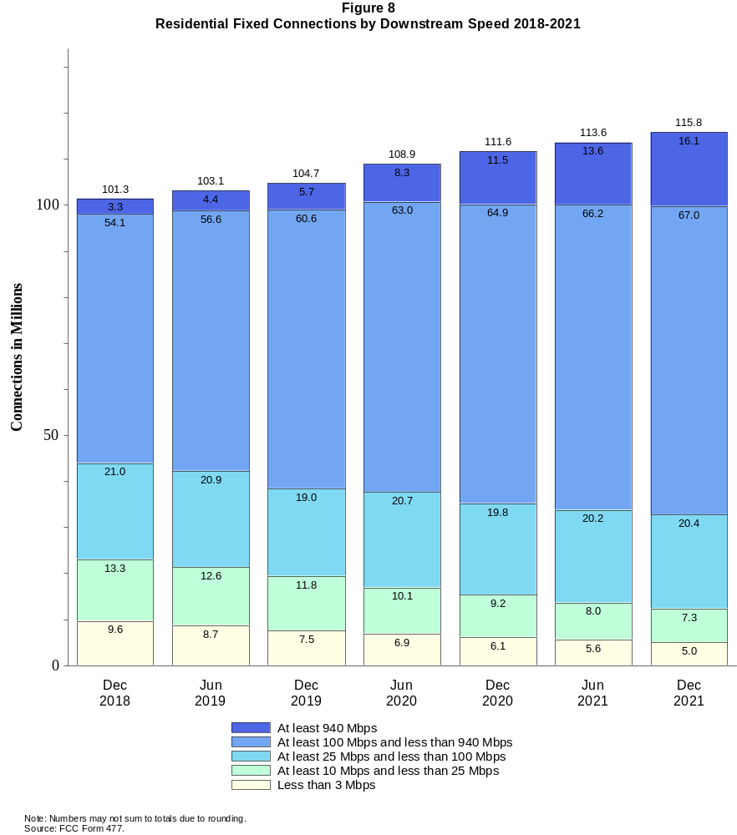

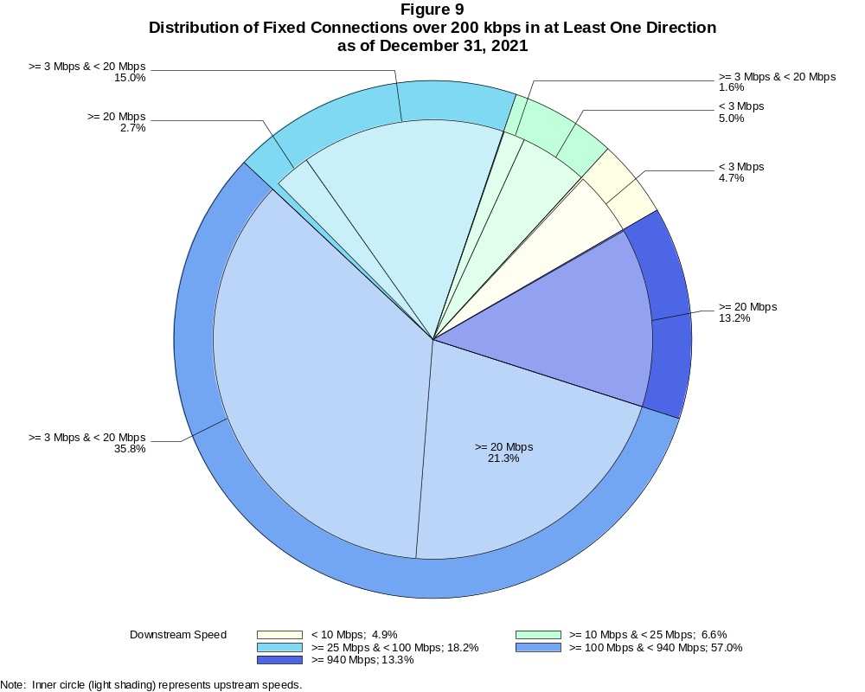

Fixed Connections over 200 kbps in at Least One Direction (in thousands)

 | Downstream Speed
Upstream Speed | Less than 10 Mbps | At least 10 Mbps  and less than 25 Mbps | At least 25 Mbps  and less than 100 Mbps | At least 100 Mbps  and less than 940 Mbps | At least 940 Mbps | Total
Less than 3 Mbps | 5,908 | 6,272 | 728 | 11 | # | 12,920
At least 3 Mbps & Less than 20 Mbps | 204 | 1,950 | 18,852 | 44,966 | 118 | 66,090
At least 20 Mbps | 2 | 75 | 3,339 | 26,775 | 16,577 | 46,767
Total | 6,114 | 8,297 | 22,919 | 71,752 | 16,695 | 125,777

Percentages

Less than 3 Mbps | 4.7 | 5.0 | 0.6 | 0.0 | 0.0 | 10.3
At least 3 Mbps & Less than 20 Mbps | 0.2 | 1.6 | 15.0 | 35.8 | 0.1 | 52.5
At least 20 Mbps | 0.0 | 0.1 | 2.7 | 21.3 | 13.2 | 37.2
Total | 4.9 | 6.6 | 18.2 | 57.0 | 13.3 | 100.0
Note: Numbers may not sum to totals due to rounding. # = Rounds to zero.
Source: FCC Form 477.

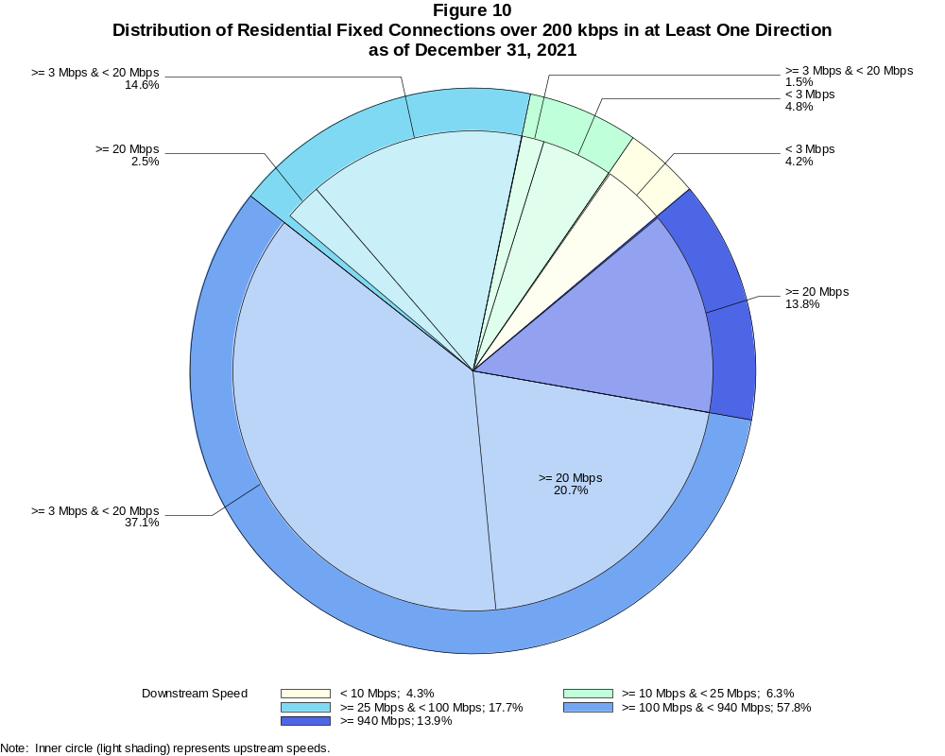

Residential Fixed Connections over 200 kbps in at Least One Direction (in thousands)

 | Downstream Speed
Upstream Speed | Less than 10 Mbps | At least 10 Mbps  and less than 25 Mbps | At least 25 Mbps  and less than 100 Mbps | At least 100 Mbps  and less than 940 Mbps | At least 940 Mbps | Total
Less than 3 Mbps | 4,878 | 5,550 | 669 | 10 | # | 11,108
At least 3 Mbps & Less than 20 Mbps | 121 | 1,724 | 16,890 | 42,998 | 114 | 61,848
At least 20 Mbps | 2 | 33 | 2,880 | 23,959 | 15,962 | 42,836
Total | 5,001 | 7,307 | 20,440 | 66,967 | 16,077 | 115,792

Percentages

Less than 3 Mbps | 4.2 | 4.8 | 0.6 | 0.0 | 0.0 | 9.6
At least 3 Mbps & Less than 20 Mbps | 0.1 | 1.5 | 14.6 | 37.1 | 0.1 | 53.4
At least 20 Mbps | 0.0 | 0.0 | 2.5 | 20.7 | 13.8 | 37.0
Total | 4.3 | 6.3 | 17.7 | 57.8 | 13.9 | 100.0
Note: Numbers may not sum to totals due to rounding. # = Rounds to zero.
Source: FCC Form 477.

Figure 11
Connections over 200 kbps in at Least One Direction by Technology 2017-2021
(in thousands)

 | 2017 | 2018 |  | 2019 |  | 2020 |  | 2021
Technology | Dec | Jun | Dec | Jun | Dec | Jun | Dec | Jun | Dec
Total | 420,838 | 428,864 | 451,062 | 459,327 | 466,302 | 480,185 | 490,888 | 500,261 | 510,198
Total Fixed | 108,065 | 109,087 | 110,784 | 112,725 | 114,291 | 118,449 | 121,250 | 123,425 | 125,777
aDSL | 24,193 | 23,074 | 22,377 | 21,163 | 20,214 | 19,639 | 18,786 | 18,085 | 16,868
sDSL | 28 | 28 | 20 | 17 | 16 | 19 | 13 | 18 | 14
Other Wireline¹ | 581 | 558 | 557 | 501 | 525 | 516 | 527 | 517 | 530
Cable Modem | 66,196 | 67,165 | 68,882 | 70,750 | 72,516 | 75,986 | 77,909 | 79,330 | 80,232
FTTP² | 13,890 | 14,889 | 15,492 | 16,748 | 17,376 | 18,443 | 19,945 | 21,120 | 23,338
Satellite | 1,872 | 1,939 | 1,971 | 1,984 | 1,975 | 1,993 | 1,931 | 1,910 | 1,873
Fixed Wireless | 1,306 | 1,434 | 1,485 | 1,561 | 1,669 | 1,853 | 2,140 | 2,445 | 2,923
Mobile Wireless | 312,773 | 319,776 | 340,278 | 346,603 | 352,012 | 361,737 | 369,638 | 376,835 | 384,420

¹ Power Line and Other are summarized with Other Wireline for confidentiality reasons. See Technical Notes at the end of the report for a description of
FCC Form 477 technology categories and other reporting requirements.
² Fiber to the premises.
Note: Some previously-published data may have been revised. Numbers may not sum to totals due to rounding.
Source: FCC Form 477.

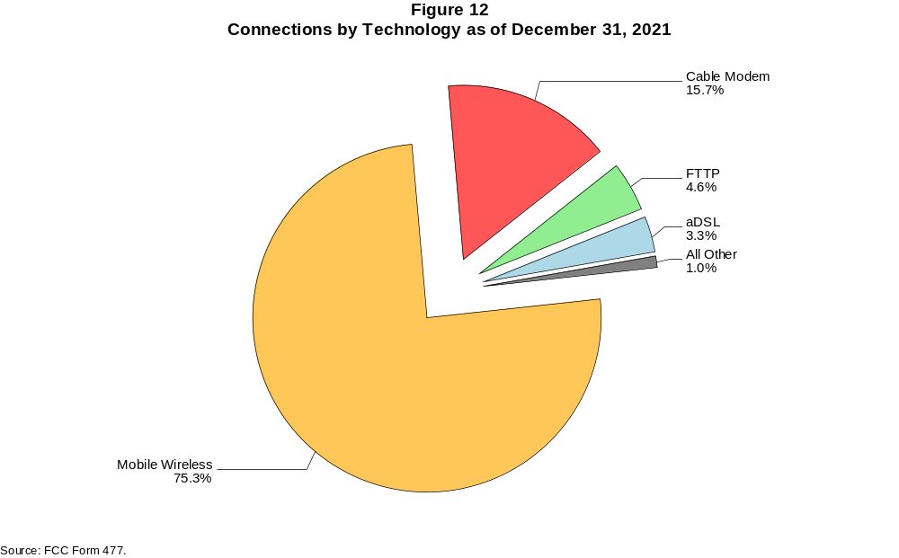

Figure 13
Residential Connections over 200 kbps in at Least One Direction by Technology 2017-2021
(in thousands)

 | 2017 | 2018 |  | 2019 |  | 2020 |  | 2021
Technology | Dec | Jun | Dec | Jun | Dec | Jun | Dec | Jun | Dec
Total | 351,966 | 358,867 | 378,286 | 383,605 | 388,344 | 403,212 | 407,652 | 415,260 | 436,576
Total Fixed | 98,845 | 99,758 | 101,348 | 103,118 | 104,703 | 108,909 | 111,621 | 113,581 | 115,792
aDSL | 21,653 | 20,671 | 20,126 | 18,976 | 18,159 | 17,647 | 16,920 | 16,278 | 15,186
sDSL | 9 | 9 | 4 | 4 | 5 | 7 | 3 | 4 | 3
Other Wireline¹ | 67 | 74 | 76 | 62 | 74 | 64 | 59 | 63 | 80
Cable Modem | 61,567 | 62,320 | 63,813 | 65,457 | 67,141 | 70,710 | 72,543 | 73,844 | 74,599
FTTP² | 12,702 | 13,663 | 14,205 | 15,410 | 16,011 | 16,971 | 18,384 | 19,414 | 21,531
Satellite | 1,688 | 1,751 | 1,787 | 1,805 | 1,795 | 1,815 | 1,752 | 1,728 | 1,692
Fixed Wireless | 1,158 | 1,270 | 1,338 | 1,405 | 1,520 | 1,694 | 1,958 | 2,251 | 2,701
Mobile Wireless | 253,121 | 259,109 | 276,938 | 280,486 | 283,641 | 294,303 | 296,031 | 301,679 | 320,785

¹ Power Line and Other are summarized with Other Wireline for confidentiality reasons. See Technical Notes at the end of the report for a description of
FCC Form 477 technology categories and other reporting requirements.
² Fiber to the premises.
Note: Some previously-published data may have been revised. Numbers may not sum to totals due to rounding.
Source: FCC Form 477.

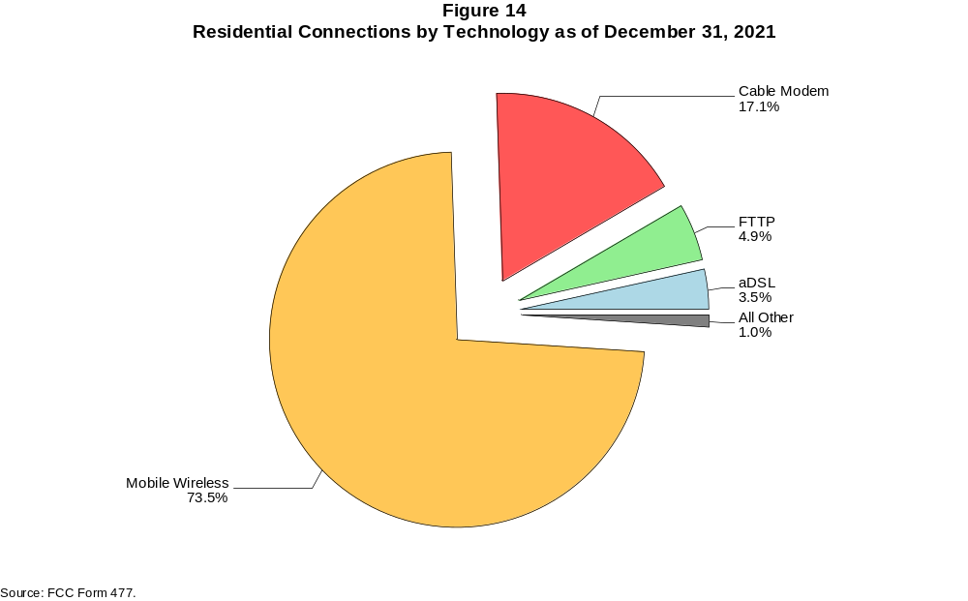

Figure 15
Fixed Connections at Least 10 Mbps Downstream and 1 Mbps Upstream by Technology 2017-2021
(in thousands)

 | 2017 | 2018 |  | 2019 |  | 2020 |  | 2021
Technology | Dec | Jun | Dec | Jun | Dec | Jun | Dec | Jun | Dec
Total | 90,609 | 94,071 | 97,302 | 100,464 | 103,595 | 109,159 | 112,445 | 115,772 | 118,773
aDSL | 11,598 | 11,822 | 12,038 | 11,829 | 11,704 | 12,421 | 11,760 | 12,017 | 11,334
sDSL | 9 | 11 | 6 | 5 | 5 | 8 | 4 | 7 | 5
Other Wireline¹ | 262 | 271 | 292 | 261 | 301 | 307 | 323 | 323 | 341
Cable Modem | 63,978 | 65,808 | 67,716 | 69,704 | 71,934 | 75,391 | 77,513 | 79,035 | 79,956
FTTP² | 12,869 | 13,898 | 14,815 | 16,078 | 16,854 | 17,993 | 19,555 | 20,813 | 23,058
Satellite | 1,402 | 1,595 | 1,677 | 1,726 | 1,737 | 1,778 | 1,727 | 1,717 | 1,700
Fixed Wireless | 491 | 666 | 759 | 861 | 1,059 | 1,263 | 1,564 | 1,860 | 2,379

¹ Power Line and Other are summarized with Other Wireline for confidentiality reasons. See Technical Notes at the end of the report for a description of
FCC Form 477 technology categories and other reporting requirements.
² Fiber to the premises.
# = Rounds to zero.
Note: Some previously-published data may have been revised. Numbers may not sum to totals due to rounding.
Source: FCC Form 477.

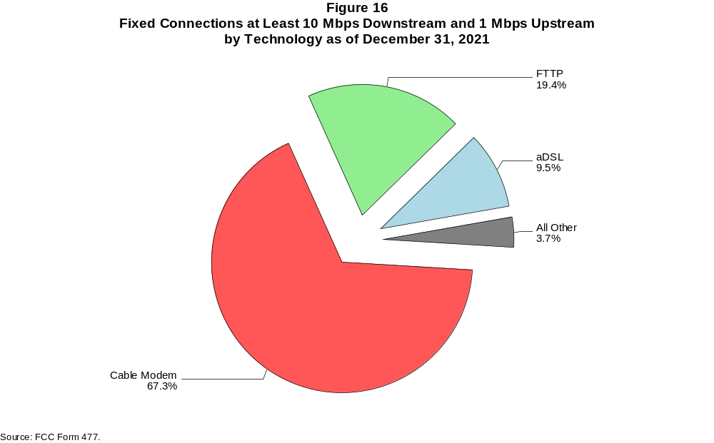

Figure 17
Residential Fixed Connections at Least 10 Mbps Downstream and 1 Mbps Upstream by Technology 2017-2021
(in thousands)

 | 2017 | 2018 |  | 2019 |  | 2020 |  | 2021
Technology | Dec | Jun | Dec | Jun | Dec | Jun | Dec | Jun | Dec
Total | 84,163 | 86,973 | 89,873 | 92,698 | 95,649 | 101,201 | 104,199 | 107,212 | 109,975
aDSL | 10,657 | 10,862 | 11,073 | 10,812 | 10,682 | 11,374 | 10,761 | 11,003 | 10,363
sDSL | 5 | 6 | 2 | 1 | 2 | 4 | 1 | 2 | 1
Other Wireline¹ | 64 | 65 | 68 | 58 | 70 | 61 | 56 | 61 | 77
Cable Modem | 59,864 | 61,142 | 62,810 | 64,556 | 66,691 | 70,299 | 72,215 | 73,611 | 74,386
FTTP² | 11,762 | 12,741 | 13,589 | 14,800 | 15,536 | 16,566 | 18,042 | 19,145 | 21,286
Satellite | 1,387 | 1,575 | 1,655 | 1,702 | 1,708 | 1,745 | 1,691 | 1,676 | 1,656
Fixed Wireless | 425 | 582 | 676 | 768 | 960 | 1,151 | 1,433 | 1,714 | 2,206

¹ Power Line and Other are summarized with Other Wireline for confidentiality reasons. See Technical Notes at the end of the report for a description of
FCC Form 477 technology categories and other reporting requirements.
² Fiber to the premises.
# = Rounds to zero.
Note: Some previously-published data may have been revised. Numbers may not sum to totals due to rounding.
Source: FCC Form 477.

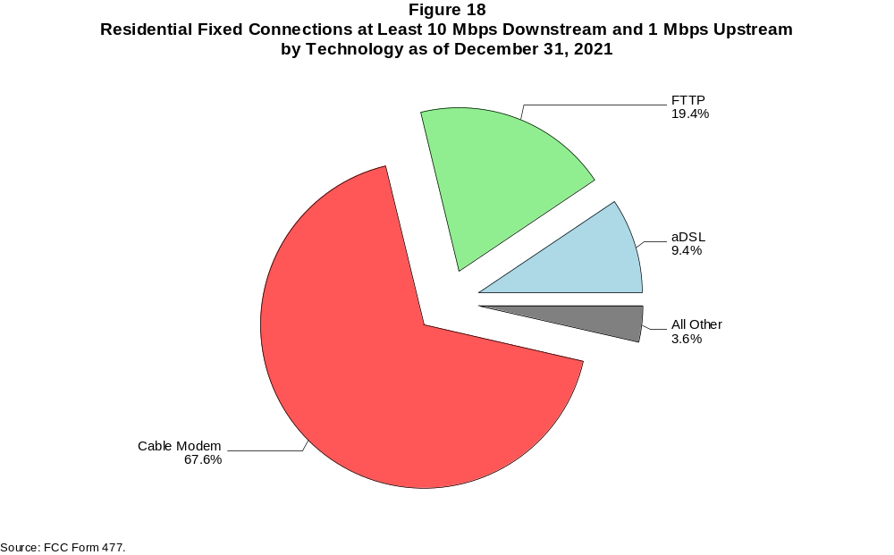

Figure 19
Fixed Connections at Least 25 Mbps Downstream and 3 Mbps Upstream by Technology 2017-2021
(in thousands)

 | 2017 | 2018 |  | 2019 |  | 2020 |  | 2021
Technology | Dec | Jun | Dec | Jun | Dec | Jun | Dec | Jun | Dec
Total | 73,875 | 78,952 | 82,965 | 86,744 | 90,471 | 96,984 | 101,630 | 106,794 | 110,627
aDSL | 3,586 | 4,298 | 4,988 | 5,233 | 5,523 | 5,910 | 6,237 | 6,397 | 6,237
sDSL | * | * | * | * | * | * | * | 2 | 2
Other Wireline¹ | 219 | 203 | 228 | 220 | 263 | 273 | 286 | 288 | 299
Cable Modem | 57,870 | 60,859 | 62,880 | 64,938 | 67,171 | 71,856 | 74,169 | 77,502 | 78,656
FTTP² | 11,489 | 12,568 | 13,605 | 14,902 | 15,866 | 17,076 | 18,840 | 20,171 | 22,459
Satellite | * | * | * | * | * | * | * | 1,328 | 1,353
Fixed Wireless | 143 | 224 | 267 | 325 | 449 | 571 | 804 | 1,105 | 1,620

¹ Power Line and Other are summarized with Other Wireline for confidentiality reasons. See Technical Notes at the end of the report for a description of
FCC Form 477 technology categories and other reporting requirements.
² Fiber to the premises.
* = Data withheld for confidentiality reasons.
# = Rounds to zero.
Note: Some previously-published data may have been revised. Numbers may not sum to totals due to rounding.
Source: FCC Form 477.

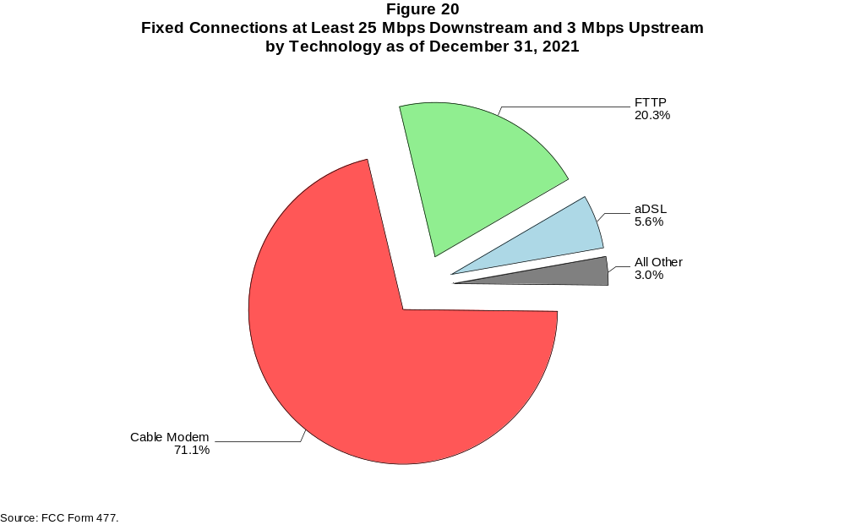

Figure 21
Residential Fixed Connections at Least 25 Mbps Downstream and 3 Mbps Upstream by Technology 2017-2021
(in thousands)

 | 2017 | 2018 |  | 2019 |  | 2020 |  | 2021
Technology | Dec | Jun | Dec | Jun | Dec | Jun | Dec | Jun | Dec
Total | 69,447 | 73,288 | 76,873 | 80,256 | 83,725 | 90,170 | 94,451 | 99,254 | 102,804
aDSL | 3,410 | 4,068 | 4,712 | 4,911 | 5,168 | 5,538 | 5,871 | 6,008 | 5,855
sDSL | * | * | * | * | * | * | * | 1 | 1
Other Wireline¹ | 59 | 54 | 61 | 53 | 64 | 56 | 51 | 58 | 74
Cable Modem | 54,748 | 56,620 | 58,342 | 60,125 | 62,231 | 67,017 | 69,098 | 72,268 | 73,262
FTTP² | 10,553 | 11,570 | 12,546 | 13,780 | 14,690 | 15,781 | 17,445 | 18,615 | 20,795
Satellite | * | * | * | * | * | * | * | 1,288 | 1,311
Fixed Wireless | 119 | 193 | 234 | 283 | 400 | 512 | 727 | 1,015 | 1,506

¹ Power Line and Other are summarized with Other Wireline for confidentiality reasons. See Technical Notes at the end of the report for a description of
FCC Form 477 technology categories and other reporting requirements.
² Fiber to the premises.
* = Data withheld for confidentiality reasons.
# = Rounds to zero.
Note: Some previously-published data may have been revised. Numbers may not sum to totals due to rounding.
Source: FCC Form 477.

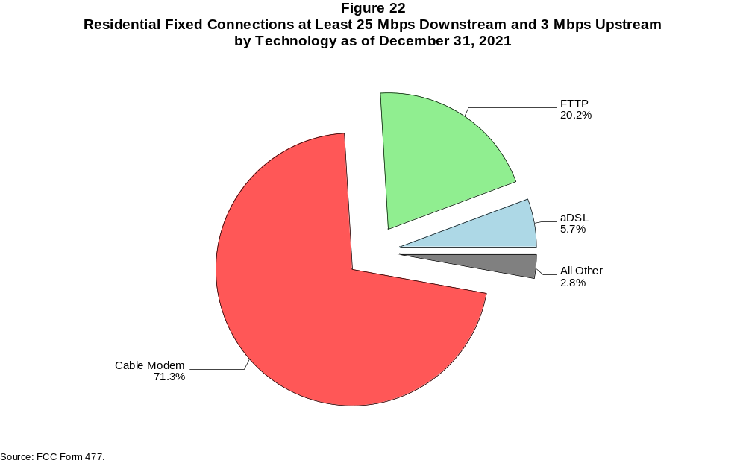

Figure 23
Fixed Connections at Least 100 Mbps Downstream and 20 Mbps Upstream by Technology 2017-2021
(in thousands)

 | 2017 | 2018 |  | 2019 |  | 2020 |  | 2021
Technology | Dec | Jun | Dec | Jun | Dec | Jun | Dec | Jun | Dec
Total | 12,148 | 14,619 | 18,750 | 22,217 | 25,603 | 29,554 | 34,493 | 38,563 | 43,352
aDSL | 47 | 59 | 207 | 387 | 569 | 658 | 774 | 867 | 885
sDSL | 1 | 1 | 1 | # | * | * | * | * | *
Other Wireline¹ | 192 | 174 | 196 | 178 | 211 | 213 | 217 | 218 | 224
Cable Modem | 7,149 | 8,352 | 9,466 | 11,426 | 13,088 | 15,496 | 18,420 | 20,924 | 23,298
FTTP² | 4,729 | 5,976 | 8,815 | 10,146 | 11,634 | 13,071 | 14,933 | 16,373 | 18,705
Satellite | 0 | 0 | 0 | 0 | * | * | * | * | *
Fixed Wireless | 30 | 56 | 65 | 79 | 101 | 116 | 143 | 180 | 239

¹ Power Line and Other are summarized with Other Wireline for confidentiality reasons. See Technical Notes at the end of the report for a description of
FCC Form 477 technology categories and other reporting requirements.
² Fiber to the premises.
* = Data withheld for confidentiality reasons.
# = Rounds to zero.
Note: Some previously-published data may have been revised. Numbers may not sum to totals due to rounding.
Source: FCC Form 477.

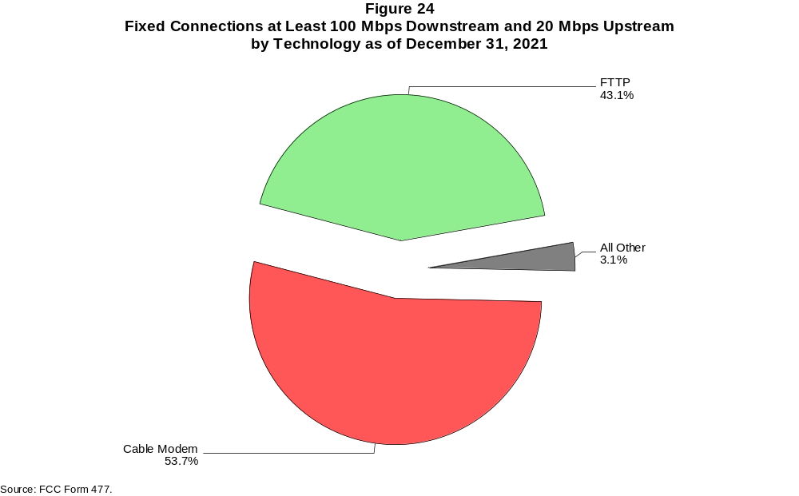

Figure 25
Residential Fixed Connections at Least 100 Mbps Downstream and 20 Mbps Upstream by Technology 2017-2021
(in thousands)

 | 2017 | 2018 |  | 2019 |  | 2020 |  | 2021
Technology | Dec | Jun | Dec | Jun | Dec | Jun | Dec | Jun | Dec
Total | 11,030 | 13,171 | 17,101 | 20,322 | 23,469 | 27,164 | 31,773 | 35,456 | 39,921
aDSL | 42 | 53 | 194 | 344 | 512 | 594 | 733 | 820 | 835
sDSL | # | # | # | # | * | * | * | * | *
Other Wireline¹ | 53 | 46 | 47 | 27 | 36 | 27 | 20 | 21 | 35
Cable Modem | 6,591 | 7,491 | 8,512 | 10,312 | 11,883 | 14,157 | 16,843 | 19,128 | 21,298
FTTP² | 4,324 | 5,534 | 8,292 | 9,574 | 10,952 | 12,288 | 14,055 | 15,329 | 17,537
Satellite | 0 | 0 | 0 | 0 | * | * | * | * | *
Fixed Wireless | 20 | 47 | 56 | 65 | 86 | 98 | 118 | 158 | 215

¹ Power Line and Other are summarized with Other Wireline for confidentiality reasons. See Technical Notes at the end of the report for a description of
FCC Form 477 technology categories and other reporting requirements.
² Fiber to the premises.
* = Data withheld for confidentiality reasons.
# = Rounds to zero.
Note: Some previously-published data may have been revised. Numbers may not sum to totals due to rounding.
Source: FCC Form 477.

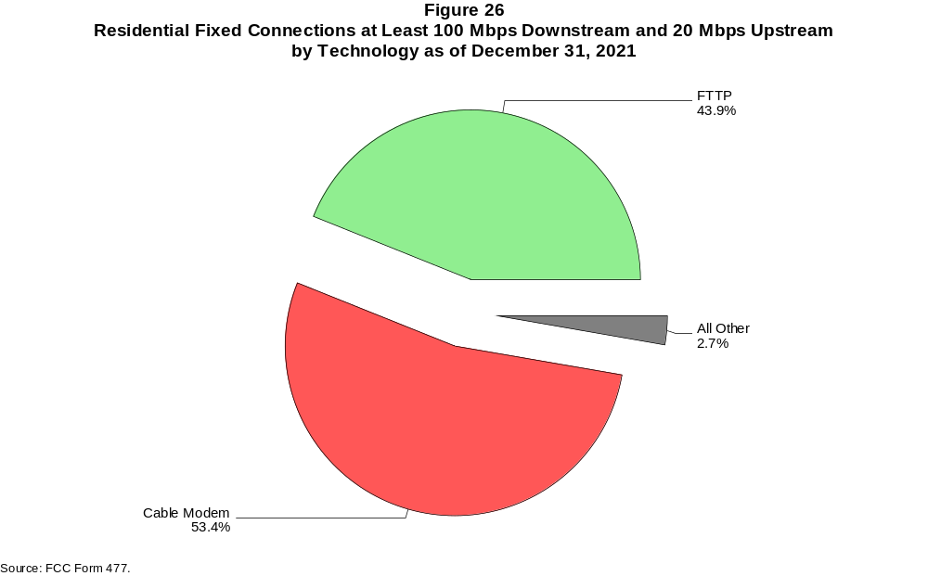

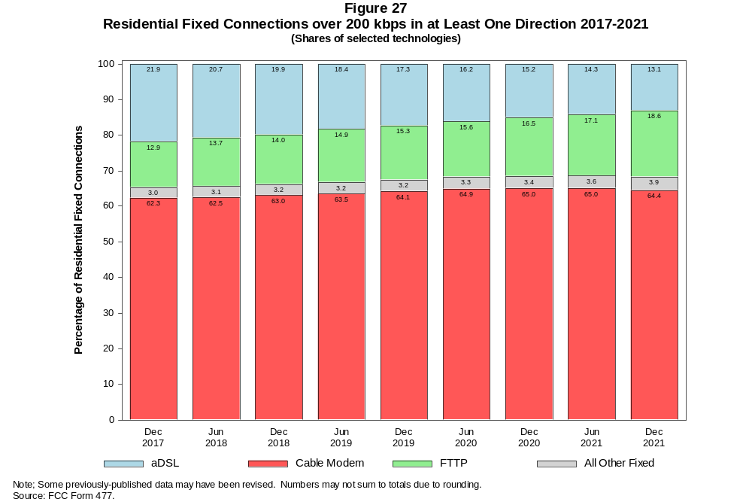

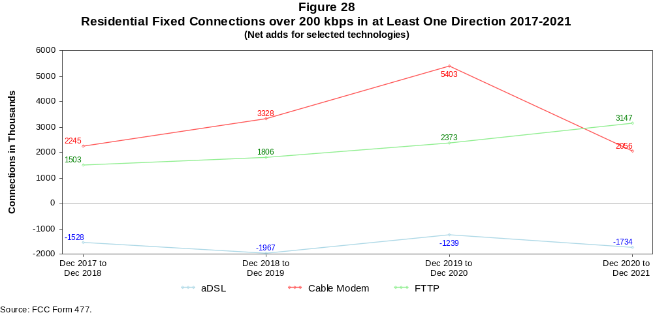

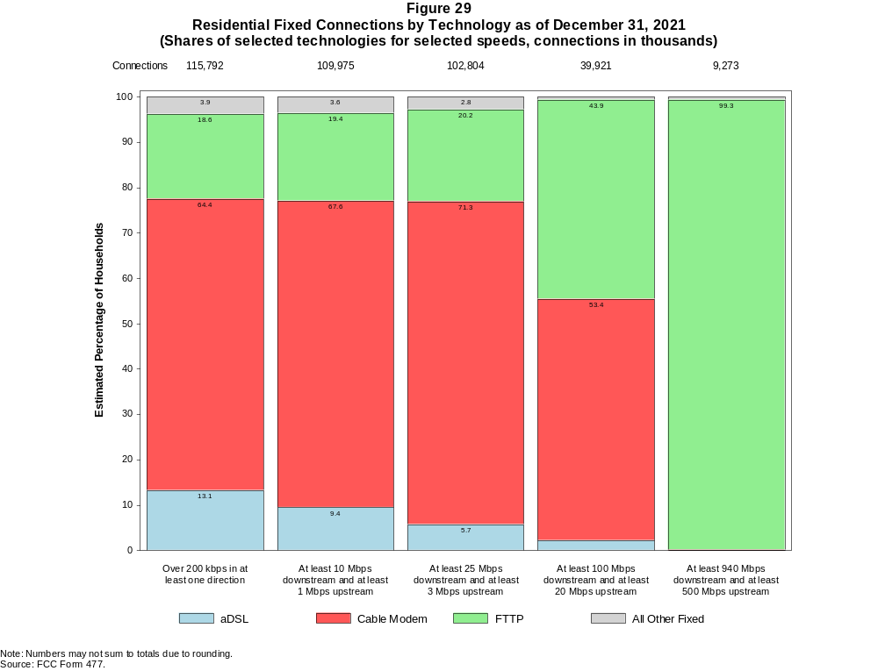

Figure 30
Fixed Connections by Downstream Speed Tier and Technology as of December 31, 2021
(in thousands)

 | Downstream Speed
Technology | Less than  4 Mbps | At least 4 Mbps  and less than  10 Mbps | At least 10 Mbps  and less than  25 Mbps | At least 25 Mbps  and less than  100 Mbps | At least 100 Mbps  and less than  940 Mbps | At least 940 Mbps | Total
aDSL | 2,065 | 2,598 | 5,425 | 5,684 | 1,096 | # | 16,868
sDSL | * | * | * | * | * | * | 14
Other Wireline¹ | 159 | 30 | 38 | 45 | 224 | 35 | 530
Cable Modem | 177 | 90 | 1,159 | 11,179 | 60,751 | 6,875 | 80,232
FTTP | 86 | 185 | 577 | 3,400 | 9,365 | 9,725 | 23,338
Satellite | * | * | * | * | * | 0 | 1,873
Fixed Wireless | 217 | 327 | 748 | 1,372 | 199 | 60 | 2,923
Total | 2,858 | 3,257 | 8,297 | 22,919 | 71,752 | 16,695 | 125,777

Percentages

aDSL | 1.6 | 2.1 | 4.3 | 4.5 | 0.9 | 0.0 | 13.4
sDSL | * | * | * | * | * | * | 0.0
Other Wireline¹ | 0.1 | 0.0 | 0.0 | 0.0 | 0.2 | 0.0 | 0.4
Cable Modem | 0.1 | 0.1 | 0.9 | 8.9 | 48.3 | 5.5 | 63.8
FTTP | 0.1 | 0.1 | 0.5 | 2.7 | 7.4 | 7.7 | 18.6
Satellite | * | * | * | * | * | 0.0 | 1.5
Fixed Wireless | 0.2 | 0.3 | 0.6 | 1.1 | 0.2 | 0.0 | 2.3
Total | 2.3 | 2.6 | 6.6 | 18.2 | 57.0 | 13.3 | 100.0

¹ Power Line and Other are summarized with Other Wireline for confidentiality reasons. See Technical Notes at the end of the report for a description of FCC Form 477 technology categories
and other reporting requirements.
# = Rounds to Zero.
* = Data withheld for confidentiality reasons.
Note: Numbers may not sum to totals due to rounding.
Source: FCC Form 477.

Figure 31
Residential Fixed Connections by Downstream Speed Tier and Technology as of December 31, 2021
(in thousands)

 | Downstream Speed
Technology | Less than  4 Mbps | At least 4 Mbps  and less than  10 Mbps | At least 10 Mbps  and less than  25 Mbps | At least 25 Mbps  and less than  100 Mbps | At least 100 Mbps  and less than  940 Mbps | At least 940 Mbps | Total
aDSL | 1,740 | 2,284 | 4,810 | 5,321 | 1,032 | # | 15,186
sDSL | * | * | * | * | * | * | 3
Other Wireline¹ | 1 | 1 | 3 | 6 | 38 | 30 | 80
Cable Modem | 147 | 59 | 988 | 9,696 | 57,075 | 6,634 | 74,599
FTTP | 71 | 166 | 471 | 2,937 | 8,527 | 9,358 | 21,531
Satellite | * | * | * | * | * | 0 | 1,692
Fixed Wireless | 195 | 299 | 690 | 1,282 | 181 | 54 | 2,701
Total | 2,167 | 2,834 | 7,307 | 20,440 | 66,967 | 16,077 | 115,792

Percentages

aDSL | 1.5 | 2.0 | 4.2 | 4.6 | 0.9 | 0.0 | 13.1
sDSL | * | * | * | * | * | * | 0.0
Other Wireline¹ | 0.0 | 0.0 | 0.0 | 0.0 | 0.0 | 0.0 | 0.1
Cable Modem | 0.1 | 0.1 | 0.9 | 8.4 | 49.3 | 5.7 | 64.4
FTTP | 0.1 | 0.1 | 0.4 | 2.5 | 7.4 | 8.1 | 18.6
Satellite | * | * | * | * | * | 0.0 | 1.5
Fixed Wireless | 0.2 | 0.3 | 0.6 | 1.1 | 0.2 | 0.0 | 2.3
Total | 1.9 | 2.4 | 6.3 | 17.7 | 57.8 | 13.9 | 100.0

¹ Power Line and Other are summarized with Other Wireline for confidentiality reasons. See Technical Notes at the end of the report for a description of FCC Form 477 technology categories
and other reporting requirements.
# = Rounds to Zero.
* = Data withheld for confidentiality reasons.
Note: Numbers may not sum to totals due to rounding.
Source: FCC Form 477.

Figure 32
Nationwide Number of Providers of Connections over 200 kbps in at Least One Direction
by Technology 2017-2021

 | 2017 | 2018 |  | 2019 |  | 2020 |  | 2021
Technology | Dec | Jun | Dec | Jun | Dec | Jun | Dec | Jun | Dec
aDSL | 743 | 738 | 721 | 715 | 691 | 677 | 653 | 638 | 610
sDSL | 150 | 136 | 127 | 123 | 121 | 118 | 106 | 102 | 87
Other Wireline¹ | 235 | 249 | 243 | 222 | 211 | 215 | 209 | 203 | 213
Cable Modem | 383 | 372 | 381 | 381 | 373 | 365 | 368 | 362 | 352
FTTP | 1,147 | 1,183 | 1,269 | 1,309 | 1,330 | 1,377 | 1,441 | 1,477 | 1,505
Satellite | 6 | 6 | 6 | 6 | 5 | 5 | 6 | 6 | 5
Fixed Wireless | 1,160 | 1,188 | 1,239 | 1,248 | 1,280 | 1,312 | 1,396 | 1,383 | 1,359
Mobile Wireless | 83 | 73 | 71 | 70 | 67 | 64 | 64 | 63 | 62
Total | 2,090 | 2,129 | 2,215 | 2,223 | 2,247 | 2,279 | 2,381 | 2,392 | 2,384

¹ Power Line and Other are summarized with Other Wireline for confidentiality reasons.
Note: Multiple FCC Form 477 filers within a holding company structure count as one provider. Some previously-published data may have been revised.
Source: FCC Form 477.

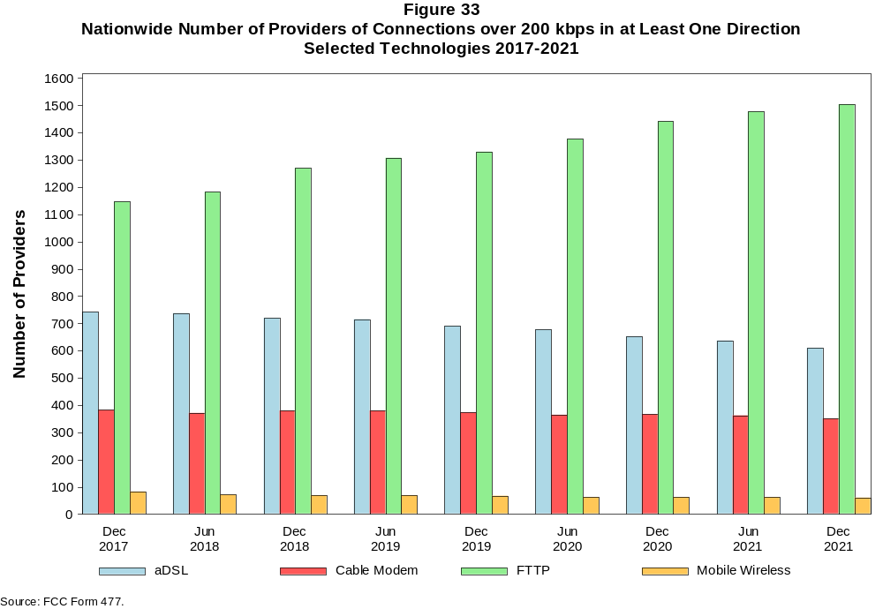

Figure 34
Residential Fixed Connections and Households by State as of December 31, 2021
(Connections and households, in thousands)

 |  | At least 200 kbps in  at least One Direction |  | At least 10 Mbps Down  and 1 Mbps Up |  | At least 25 Mbps Down  and 3 Mbps Up |  | At least 100 Mbps Down  and 20 Mbps Up |  | At least 940 Mbps Down  and 500 Mbps Up
State | Households | Connections | Subscribership  Ratio | Connections | Subscribership  Ratio | Connections | Subscribership  Ratio | Connections | Subscribership  Ratio | Connections | Subscribership  Ratio
Alabama | 1,903 | 1,645 | 0.86 | 1,508 | 0.79 | 1,356 | 0.71 | 520 | 0.27 | 153 | 0.08
Alaska | 261 | 231 | 0.89 | 215 | 0.83 | 168 | 0.64 | * | * | * | *
American Samoa | 10 | * | * | * | * | * | * | 0 | 0.00 | 0 | 0.00
Arizona | 2,684 | 2,540 | 0.95 | 2,416 | 0.90 | 2,235 | 0.83 | 526 | 0.20 | 90 | 0.03
Arkansas | 1,158 | 955 | 0.82 | 842 | 0.73 | 726 | 0.63 | 294 | 0.25 | 59 | 0.05
California | 13,218 | 12,667 | 0.96 | 12,207 | 0.92 | 11,493 | 0.87 | 3,765 | 0.28 | 641 | 0.05
Colorado | 2,228 | 2,186 | 0.98 | 2,086 | 0.94 | 1,947 | 0.87 | 530 | 0.24 | 136 | 0.06
Connecticut | 1,397 | 1,321 | 0.95 | 1,277 | 0.91 | 1,161 | 0.83 | 397 | 0.28 | 19 | 0.01
Delaware | 381 | 395 | 1.04 | 388 | 1.02 | 386 | 1.01 | 141 | 0.37 | * | *
District of Columbia | 310 | 280 | 0.90 | 274 | 0.88 | 271 | 0.88 | 117 | 0.38 | * | *
Florida | 8,157 | 8,387 | 1.03 | 8,090 | 0.99 | 7,756 | 0.95 | 3,127 | 0.38 | 468 | 0.06
Georgia | 3,885 | 3,635 | 0.94 | 3,434 | 0.88 | 3,193 | 0.82 | 1,529 | 0.39 | 411 | 0.11
Guam | 42 | * | * | * | * | * | * | * | * | 0 | 0.00
Hawaii | 478 | 499 | 1.04 | 489 | 1.02 | * | * | * | * | * | *
Idaho | 657 | 617 | 0.94 | 551 | 0.84 | 444 | 0.68 | 211 | 0.32 | 34 | 0.05
Illinois | 4,930 | 4,283 | 0.87 | 4,081 | 0.83 | 3,788 | 0.77 | 1,565 | 0.32 | 155 | 0.03
Indiana | 2,623 | 2,275 | 0.87 | 2,111 | 0.81 | 1,938 | 0.74 | 812 | 0.31 | 152 | 0.06
Iowa | 1,276 | 1,081 | 0.85 | 980 | 0.77 | 866 | 0.68 | 361 | 0.28 | 43 | 0.03
Kansas | 1,140 | 1,008 | 0.88 | 944 | 0.83 | 857 | 0.75 | 336 | 0.30 | 127 | 0.11
Kentucky | 1,748 | 1,544 | 0.88 | 1,424 | 0.81 | 1,277 | 0.73 | 501 | 0.29 | 87 | 0.05
Louisiana | 1,749 | 1,470 | 0.84 | 1,362 | 0.78 | 1,219 | 0.70 | 429 | 0.25 | 95 | 0.05
Maine | 571 | 587 | 1.03 | 541 | 0.95 | 468 | 0.82 | 68 | 0.12 | 2 | 0.00
Maryland | 2,294 | 2,171 | 0.95 | 2,126 | 0.93 | 2,094 | 0.91 | 933 | 0.41 | * | *
Massachusetts | 2,714 | 2,584 | 0.95 | 2,527 | 0.93 | 2,508 | 0.92 | 794 | 0.29 | * | *
Michigan | 3,977 | 3,533 | 0.89 | 3,348 | 0.84 | 3,132 | 0.79 | 989 | 0.25 | 77 | 0.02
Minnesota | 2,229 | 2,020 | 0.91 | 1,895 | 0.85 | 1,734 | 0.78 | 458 | 0.21 | 69 | 0.03
Mississippi | 1,109 | 869 | 0.78 | 771 | 0.70 | 631 | 0.57 | 283 | 0.26 | 104 | 0.09
Missouri | 2,434 | 2,118 | 0.87 | 1,916 | 0.79 | 1,705 | 0.70 | 759 | 0.31 | 207 | 0.09
Montana | 436 | 404 | 0.93 | 364 | 0.83 | 313 | 0.72 | 57 | 0.13 | 8 | 0.02
Nebraska | 767 | 674 | 0.88 | 634 | 0.83 | 578 | 0.75 | 199 | 0.26 | 36 | 0.05

Figure 34 - Continued
Residential Fixed Connections and Households by State as of December 31, 2021
(Connections and households, in thousands)

 |  | At least 200 kbps in  at least One Direction |  | At least 10 Mbps Down  and 1 Mbps Up |  | At least 25 Mbps Down  and 3 Mbps Up |  | At least 100 Mbps Down  and 20 Mbps Up |  | At least 940 Mbps Down  and 500 Mbps Up
State | Households | Connections | Subscribership  Ratio | Connections | Subscribership  Ratio | Connections | Subscribership  Ratio | Connections | Subscribership  Ratio | Connections | Subscribership  Ratio
Nevada | 1,142 | 1,093 | 0.96 | 1,047 | 0.92 | 990 | 0.87 | 257 | 0.22 | 44 | 0.04
New Hampshire | 540 | 562 | 1.04 | 540 | 1.00 | 511 | 0.95 | 135 | 0.25 | 6 | 0.01
New Jersey | 3,397 | 3,199 | 0.94 | 3,143 | 0.93 | 3,116 | 0.92 | 1,851 | 0.55 | * | *
New Mexico | 798 | 703 | 0.88 | 629 | 0.79 | 547 | 0.69 | 109 | 0.14 | 10 | 0.01
New York | 7,530 | 6,859 | 0.91 | 6,763 | 0.90 | 6,529 | 0.87 | 3,762 | 0.50 | * | *
North Carolina | 4,035 | 3,981 | 0.99 | 3,681 | 0.91 | 3,482 | 0.86 | 1,372 | 0.34 | 329 | 0.08
North Dakota | 317 | 283 | 0.89 | 276 | 0.87 | 267 | 0.84 | 151 | 0.48 | 7 | 0.02
Northern Mariana Isl | 16 | * | * | * | * | * | * | 0 | 0.00 | 0 | 0.00
Ohio | 4,754 | 4,266 | 0.90 | 4,034 | 0.85 | 3,714 | 0.78 | 1,029 | 0.22 | 101 | 0.02
Oklahoma | 1,504 | 1,258 | 0.84 | 1,150 | 0.76 | 1,022 | 0.68 | 369 | 0.25 | 104 | 0.07
Oregon | 1,658 | 1,560 | 0.94 | 1,464 | 0.88 | 1,374 | 0.83 | 358 | 0.22 | 79 | 0.05
Pennsylvania | 5,148 | 4,649 | 0.90 | 4,397 | 0.85 | 4,287 | 0.83 | 1,478 | 0.29 | * | *
Puerto Rico | 1,197 | 662 | 0.55 | 579 | 0.48 | 380 | 0.32 | 125 | 0.10 | * | *
Rhode Island | 427 | 403 | 0.95 | 401 | 0.94 | 399 | 0.94 | 206 | 0.48 | * | *
South Carolina | 1,976 | 1,919 | 0.97 | 1,825 | 0.92 | 1,681 | 0.85 | 697 | 0.35 | 104 | 0.05
South Dakota | 346 | 311 | 0.90 | 303 | 0.88 | 291 | 0.84 | 114 | 0.33 | 2 | 0.01
Tennessee | 2,665 | 2,404 | 0.90 | 2,287 | 0.86 | 2,155 | 0.81 | 1,042 | 0.39 | 302 | 0.11
Texas | 10,239 | 9,605 | 0.94 | 9,235 | 0.90 | 8,558 | 0.84 | 4,063 | 0.40 | 1,160 | 0.11
Utah | 1,034 | 989 | 0.96 | 948 | 0.92 | 887 | 0.86 | 314 | 0.30 | 91 | 0.09
Vermont | 263 | 269 | 1.02 | 237 | 0.90 | 200 | 0.76 | 42 | 0.16 | 13 | 0.05
Virgin Islands | 43 | * | * | * | * | * | * | * | * | 0 | 0.00
Virginia | 3,249 | 2,953 | 0.91 | 2,802 | 0.86 | 2,734 | 0.84 | 1,135 | 0.35 | * | *
Washington | 2,932 | 2,852 | 0.97 | 2,677 | 0.91 | 2,524 | 0.86 | 648 | 0.22 | 151 | 0.05
West Virginia | 711 | 568 | 0.80 | 491 | 0.69 | 428 | 0.60 | 145 | 0.20 | 4 | 0.01
Wisconsin | 2,402 | 2,166 | 0.90 | 1,997 | 0.83 | 1,781 | 0.74 | 448 | 0.19 | 56 | 0.02
Wyoming | 231 | 214 | 0.93 | 198 | 0.86 | 181 | 0.78 | 39 | 0.17 | 1 | 0.01
Total | 125,319 | 115,792 | 0.92 | 109,975 | 0.88 | 102,804 | 0.82 | 39,921 | 0.32 | 9,273 | 0.07

# = Rounds to Zero; * = Data withheld for confidentiality reasons.
Note: Numbers may not sum to totals due to rounding.
Sources: FCC Form 477 (Connections); 2017-2021 ACS 5-year estimates; Census 2010.

Figure 35
Connections by Type of End User by State as of December 31, 2021
(Connections over 200 kbps in at least one direction, in thousands)

 | Connections |  | Percentages
State | Residential | Business | Residential | Business | Total
Alabama | 6,379 | 990 | 86.6 | 13.4 | 7,369
Alaska | 892 | 143 | 86.2 | 13.8 | 1,034
American Samoa | * | * | * | * | *
Arizona | 9,304 | 1,378 | 87.1 | 12.9 | 10,682
Arkansas | 3,771 | 527 | 87.7 | 12.3 | 4,298
California | 52,547 | 9,514 | 84.7 | 15.3 | 62,061
Colorado | 7,431 | 1,428 | 83.9 | 16.1 | 8,859
Connecticut | 4,903 | 853 | 85.2 | 14.8 | 5,756
Delaware | 1,354 | 228 | 85.6 | 14.4 | 1,581
District of Columbia | 1,118 | 654 | 63.1 | 36.9 | 1,773
Florida | 30,113 | 4,557 | 86.9 | 13.1 | 34,670
Georgia | 14,220 | 2,319 | 86.0 | 14.0 | 16,539
Guam | * | * | * | * | *
Hawaii | 1,913 | 329 | 85.3 | 14.7 | 2,242
Idaho | 2,240 | 329 | 87.2 | 12.8 | 2,569
Illinois | 16,612 | 3,075 | 84.4 | 15.6 | 19,687
Indiana | 8,338 | 1,269 | 86.8 | 13.2 | 9,607
Iowa | 3,889 | 623 | 86.2 | 13.8 | 4,512
Kansas | 3,674 | 549 | 87.0 | 13.0 | 4,223
Kentucky | 5,590 | 803 | 87.4 | 12.6 | 6,392
Louisiana | 6,113 | 846 | 87.8 | 12.2 | 6,959
Maine | 1,738 | 308 | 84.9 | 15.1 | 2,046
Maryland | 8,250 | 1,339 | 86.0 | 14.0 | 9,589
Massachusetts | 9,139 | 1,712 | 84.2 | 15.8 | 10,851
Michigan | 12,735 | 2,213 | 85.2 | 14.8 | 14,948
Minnesota | 7,135 | 1,262 | 85.0 | 15.0 | 8,397
Mississippi | 3,800 | 471 | 89.0 | 11.0 | 4,270
Missouri | 7,768 | 1,229 | 86.3 | 13.7 | 8,997
Montana | 1,342 | 226 | 85.6 | 14.4 | 1,568
Nebraska | 2,389 | 467 | 83.6 | 16.4 | 2,856
Nevada | 4,205 | 550 | 88.4 | 11.6 | 4,756
New Hampshire | 1,771 | 337 | 84.0 | 16.0 | 2,107
New Jersey | 12,436 | 2,178 | 85.1 | 14.9 | 14,614
New Mexico | 2,695 | 390 | 87.4 | 12.6 | 3,085
New York | 26,941 | 5,346 | 83.4 | 16.6 | 32,287
North Carolina | 13,467 | 2,284 | 85.5 | 14.5 | 15,751
North Dakota | 975 | 161 | 85.9 | 14.1 | 1,136
Northern Mariana Isl | * | * | * | * | *
Ohio | 15,127 | 2,618 | 85.2 | 14.8 | 17,745
Oklahoma | 4,992 | 728 | 87.3 | 12.7 | 5,720
Oregon | 5,394 | 979 | 84.6 | 15.4 | 6,373
Pennsylvania | 16,576 | 2,882 | 85.2 | 14.8 | 19,458
Puerto Rico | 3,953 | 291 | 93.1 | 6.9 | 4,244
Rhode Island | 1,441 | 273 | 84.1 | 15.9 | 1,713
South Carolina | 6,588 | 953 | 87.4 | 12.6 | 7,540
South Dakota | 1,096 | 162 | 87.1 | 12.9 | 1,259
Tennessee | 8,964 | 1,379 | 86.7 | 13.3 | 10,343
Texas | 39,453 | 5,979 | 86.8 | 13.2 | 45,432
Utah | 3,744 | 734 | 83.6 | 16.4 | 4,478
Vermont | 781 | 176 | 81.6 | 18.4 | 957
Virgin Islands | 105 | 12 | 89.6 | 10.4 | 117
Virginia | 11,053 | 2,048 | 84.4 | 15.6 | 13,101
Washington | 9,946 | 1,755 | 85.0 | 15.0 | 11,701
West Virginia | 2,064 | 259 | 88.8 | 11.2 | 2,323
Wisconsin | 7,125 | 1,230 | 85.3 | 14.7 | 8,355
Wyoming | 755 | 121 | 86.2 | 13.8 | 875
Total | 436,576 | 73,621 | 85.6 | 14.4 | 510,198

# = Rounds to Zero.
* = Data withheld for confidentiality reasons.
Note: Numbers may not sum to totals due to rounding.
Source: FCC Form 477.

Figure 36
Connections by Technology by State as of December 31, 2021
(Connections over 200 kbps in at least one direction, in thousands)

State | ADSL | SDSL | Other  Wireline¹ | Cable  Modem | Fiber | Satellite | Fixed  Wireless | Mobile  Wireless | Total
Alabama | 363 | * | 5 | 1,011 | 328 | * | 22 | 5,580 | 7,369
Alaska | 63 | * | 8 | * | 15 | 6 | 14 | 766 | 1,034
American Samoa | 0 | 0 | 0 | * | * | 0 | * | * | *
Arizona | 520 | # | * | 1,823 | 225 | * | 93 | 7,969 | 10,682
Arkansas | 300 | * | 4 | 477 | 192 | * | 20 | 3,259 | 4,298
California | 1,969 | 3 | * | 9,621 | 1,731 | * | 287 | 48,243 | 62,061
Colorado | * | # | 17 | 1,600 | 238 | * | 115 | 6,491 | 8,859
Connecticut | * | * | 2 | 1,165 | 74 | * | 7 | 4,316 | 5,756
Delaware | * | * | * | 279 | * | * | 2 | * | 1,581
District of Columbia | * | * | 6 | * | * | * | 9 | 1,458 | 1,773
Florida | 1,050 | # | * | 6,344 | 1,516 | * | 71 | 25,581 | 34,670
Georgia | 731 | * | 8 | 2,273 | 838 | * | 35 | 12,584 | 16,539
Guam | * | 0 | 0 | * | * | 0 | * | * | *
Hawaii | * | * | 1 | * | * | * | 2 | 1,688 | 2,242
Idaho | 195 | # | * | 294 | 83 | * | 76 | 1,900 | 2,569
Illinois | 803 | 1 | * | 3,222 | 403 | * | 144 | 15,061 | 19,687
Indiana | 434 | # | * | 1,428 | 467 | * | 76 | 7,155 | 9,607
Iowa | 248 | # | * | 507 | 321 | * | 67 | 3,333 | 4,512
Kansas | 170 | # | * | 544 | 297 | * | 63 | 3,129 | 4,223
Kentucky | 318 | * | 2 | 924 | 360 | * | 33 | 4,719 | 6,392
Louisiana | 324 | * | 4 | 938 | 251 | * | 28 | 5,358 | 6,959
Maine | 98 | # | * | 496 | 31 | * | 10 | 1,395 | 2,046
Maryland | * | * | 14 | 1,323 | * | * | 21 | 7,248 | 9,589
Massachusetts | 62 | # | * | 2,108 | 598 | * | 28 | 8,034 | 10,851
Michigan | 606 | 1 | * | 2,794 | 243 | * | 83 | 11,131 | 14,948
Minnesota | 405 | 1 | * | 1,359 | 322 | * | 68 | 6,211 | 8,397
Mississippi | 301 | * | 11 | 394 | 180 | * | 19 | 3,304 | 4,270
Missouri | 491 | # | * | 1,152 | 486 | * | 86 | 6,706 | 8,997
Montana | 86 | * | 2 | 255 | 51 | * | 37 | 1,118 | 1,568
Nebraska | 118 | # | * | 400 | 163 | * | 44 | 2,120 | 2,856

Figure 36 - Continued
Connections by Technology by State as of December 31, 2021
(Connections over 200 kbps in at least one direction, in thousands)

State | ADSL | SDSL | Other  Wireline¹ | Cable  Modem | Fiber | Satellite | Fixed  Wireless | Mobile  Wireless | Total
Nevada | 144 | * | 5 | * | 123 | * | 43 | 3,574 | 4,756
New Hampshire | 48 | # | * | 513 | 53 | * | 4 | 1,480 | 2,107
New Jersey | 71 | * | 23 | 2,165 | * | * | 16 | 11,113 | 14,614
New Mexico | 207 | # | * | 436 | 57 | * | 40 | 2,323 | 3,085
New York | 172 | 1 | * | 5,066 | 2,164 | * | 45 | 24,767 | 32,287
North Carolina | 574 | # | * | 2,855 | 736 | * | 47 | 11,455 | 15,751
North Dakota | 22 | * | # | 174 | 118 | * | 4 | 815 | 1,136
Northern Mariana Isl | * | 0 | * | * | * | 0 | * | * | *
Ohio | 709 | * | 8 | 3,207 | 516 | * | 101 | 13,159 | 17,745
Oklahoma | 297 | * | 2 | 674 | 274 | * | 80 | 4,345 | 5,720
Oregon | 195 | # | * | 1,155 | 256 | * | 46 | 4,674 | 6,373
Pennsylvania | 360 | * | 23 | 3,433 | 1,134 | * | 45 | 14,423 | 19,458
Puerto Rico | * | 0 | 2 | * | 95 | * | 76 | 3,518 | 4,244
Rhode Island | * | * | * | * | * | * | * | * | 1,713
South Carolina | 313 | * | 4 | 1,296 | 400 | * | 22 | 5,470 | 7,540
South Dakota | 31 | * | 1 | 201 | 91 | * | 11 | 917 | 1,259
Tennessee | 348 | # | * | 1,459 | 713 | * | 34 | 7,731 | 10,343
Texas | 1,441 | # | * | 5,744 | 2,591 | * | 412 | 35,023 | 45,432
Utah | 138 | * | 7 | 620 | 227 | * | 70 | 3,410 | 4,478
Vermont | 77 | * | 3 | 177 | 43 | * | 4 | 647 | 957
Virgin Islands | 0 | 0 | 0 | * | * | * | * | 82 | 117
Virginia | 193 | # | * | 1,760 | 1,104 | * | 54 | 9,892 | 13,101
Washington | 368 | # | * | 2,218 | 302 | * | 79 | 8,636 | 11,701
West Virginia | * | * | 1 | 425 | 19 | * | 12 | 1,707 | 2,323
Wisconsin | 468 | * | 3 | * | 276 | * | 70 | 6,008 | 8,355
Wyoming | 39 | * | 1 | 134 | 18 | * | 39 | 636 | 875
Total | 16,868 | 14 | 530 | 80,232 | 23,338 | 1,873 | 2,923 | 384,420 | 510,198

¹ PowerLine and Other are summarized with Other Wireline for confidentiality reasons. See Technical Notes at the end of the report for a description of FCC Form 477 technology categories and
other reporting requirements.
# = Rounds to Zero.
* = Data withheld for confidentiality reasons.
Note: Numbers may not sum to totals due to rounding.
Source: FCC Form 477.

Figure 37
Percentage of Fixed Connections by Downstream Speed by State as of December 31, 2021

 | Over 200 kbps Upstream and
State | % over 200 kbps  Downstream | % at least 10 Mbps  Downstream | % at least 25 Mbps  Downstream | % at least 100 Mbps  Downstream | % at least 940 Mbps  Downstream
Alabama | 99.8 | 92.7 | 83.4 | 64.7 | 11.3
Alaska | 99.8 | 91.9 | 72.7 | * | *
American Samoa | * | * | * | * | *
Arizona | 99.9 | 95.9 | 88.4 | 61.8 | 12.9
Arkansas | 99.8 | 90.2 | 76.4 | 47.0 | 10.8
California | 99.8 | 95.7 | 89.6 | 72.2 | 11.6
Colorado | 99.9 | 96.4 | 89.1 | 68.3 | 16.9
Connecticut | 99.8 | 96.0 | 88.5 | 77.0 | 10.8
Delaware | 99.9 | 97.5 | 96.9 | 82.2 | 24.2
District of Columbia | 100.0 | 96.1 | 94.8 | 78.2 | 23.4
Florida | 99.8 | 97.1 | 92.5 | 72.7 | 9.4
Georgia | 99.6 | 94.2 | 87.6 | 67.0 | 16.1
Guam | * | * | * | * | *
Hawaii | 100.0 | 96.6 | * | * | *
Idaho | 99.8 | 91.2 | 73.2 | 52.3 | 8.9
Illinois | 99.8 | 95.0 | 88.0 | 64.9 | 10.2
Indiana | 99.6 | 93.4 | 85.0 | 61.3 | 10.6
Iowa | 99.3 | 91.9 | 80.6 | 55.5 | 10.6
Kansas | 99.8 | 94.2 | 84.3 | 58.3 | 15.9
Kentucky | 99.7 | 92.3 | 83.4 | 64.4 | 6.9
Louisiana | 99.8 | 93.0 | 83.2 | 58.0 | 11.9
Maine | 99.3 | 90.9 | 80.7 | 68.4 | 3.0
Maryland | 99.9 | 97.2 | 95.6 | 80.2 | 27.4
Massachusetts | 100.0 | 97.2 | 96.3 | 85.2 | 20.2
Michigan | 99.5 | 94.5 | 88.2 | 67.4 | 7.2
Minnesota | 99.8 | 95.1 | 86.5 | 63.9 | 9.2
Mississippi | 99.7 | 88.8 | 73.4 | 47.5 | 15.7
Missouri | 99.6 | 92.5 | 81.3 | 63.3 | 12.2
Montana | 99.9 | 92.4 | 78.4 | 57.3 | 2.7
Nebraska | 99.6 | 94.6 | 85.7 | 63.4 | 9.0

Figure 37 - Continued
Percentage of Fixed Connections by Downstream Speed by State as of December 31, 2021

 | Over 200 kbps Upstream and
State | % over 200 kbps  Downstream | % at least 10 Mbps  Downstream | % at least 25 Mbps  Downstream | % at least 100 Mbps  Downstream | % at least 940 Mbps  Downstream
Nevada | 100.0 | 96.7 | 91.3 | 67.6 | 13.9
New Hampshire | 99.6 | 94.7 | 90.8 | 81.0 | 12.5
New Jersey | 99.8 | 97.8 | 96.6 | 87.3 | 25.8
New Mexico | 99.9 | 91.8 | 78.9 | 51.3 | 7.1
New York | 99.8 | 97.9 | 94.4 | 86.0 | 16.1
North Carolina | 99.5 | 94.0 | 87.4 | 74.6 | 9.5
North Dakota | 99.9 | 97.7 | 93.2 | 76.4 | 7.4
Northern Mariana Isl | * | * | * | * | *
Ohio | 99.8 | 94.8 | 86.7 | 68.3 | 4.2
Oklahoma | 99.6 | 91.3 | 80.2 | 55.8 | 13.7
Oregon | 99.8 | 94.9 | 88.0 | 68.9 | 13.1
Pennsylvania | 99.8 | 94.9 | 92.3 | 75.2 | 18.4
Puerto Rico | 100.0 | 86.0 | 59.5 | 26.3 | 1.2
Rhode Island | 99.6 | 98.9 | 97.9 | 82.6 | 29.5
South Carolina | 99.8 | 95.3 | 87.6 | 72.5 | 7.5
South Dakota | 99.8 | 97.9 | 93.8 | 67.1 | 6.9
Tennessee | 99.7 | 95.1 | 89.1 | 69.9 | 15.8
Texas | 99.9 | 96.2 | 88.8 | 69.8 | 16.7
Utah | 100.0 | 96.5 | 89.7 | 68.8 | 18.9
Vermont | 99.1 | 86.0 | 75.6 | 61.4 | 11.3
Virgin Islands | * | * | * | * | *
Virginia | 99.5 | 95.0 | 91.6 | 74.6 | 24.7
Washington | 99.7 | 94.9 | 88.4 | 71.6 | 16.4
West Virginia | 98.1 | 85.9 | 75.7 | 59.2 | 9.2
Wisconsin | 99.2 | 93.5 | 82.5 | 66.5 | 3.3
Wyoming | 99.9 | 93.8 | 84.7 | 62.2 | 1.6
Total | 99.7 | 95.1 | 88.5 | 70.3 | 13.3

Source: FCC Form 477.

Figure 38
Providers of Connections by Technology by State as of December 31, 2021
(Connections over 200 kbps in at least one direction, in thousands)

State | ADSL | SDSL | Other  Wireline¹ | Cable  Modem | Fiber | Satellite | Fixed  Wireless | Mobile  Wireless | Total
Alabama | 23 | * | 13 | 17 | 50 | * | 30 | 6 | 86
Alaska | 16 | * | 6 | * | 21 | 4 | 18 | 10 | 41
American Samoa | 0 | 0 | 0 | * | * | 0 | * | * | *
Arizona | 19 | 4 | * | 18 | 58 | * | 54 | 6 | 106
Arkansas | 23 | * | 12 | 17 | 60 | * | 38 | 5 | 100
California | 32 | 9 | * | 35 | 95 | * | 138 | 5 | 222
Colorado | * | 6 | 20 | 17 | 84 | * | 74 | 9 | 142
Connecticut | * | * | 9 | 10 | 24 | * | 11 | 4 | 41
Delaware | * | * | * | 5 | * | * | 5 | * | 36
District of Columbia | * | * | 14 | * | * | * | 10 | 4 | 45
Florida | 15 | 4 | * | 21 | 82 | * | 51 | 6 | 125
Georgia | 25 | * | 18 | 28 | 93 | * | 33 | 5 | 128
Guam | * | 0 | 0 | * | * | 0 | * | * | *
Hawaii | * | * | 8 | * | * | * | 6 | 5 | 24
Idaho | 24 | 4 | * | 18 | 47 | * | 46 | 8 | 80
Illinois | 49 | 7 | * | 22 | 100 | * | 95 | 6 | 179
Indiana | 33 | 6 | * | 15 | 89 | * | 67 | 4 | 134
Iowa | 61 | 9 | * | 38 | 182 | * | 85 | 6 | 232
Kansas | 28 | 4 | * | 24 | 75 | * | 69 | 8 | 126
Kentucky | 18 | * | 16 | 31 | 69 | * | 36 | 7 | 117
Louisiana | 16 | * | 15 | 18 | 42 | * | 30 | 6 | 80
Maine | 12 | 5 | * | 8 | 22 | * | 15 | 5 | 41
Maryland | * | * | 18 | 16 | * | * | 31 | 5 | 84
Massachusetts | 8 | 4 | * | 10 | 41 | * | 23 | 4 | 63
Michigan | 27 | 5 | * | 28 | 86 | * | 64 | 7 | 137
Minnesota | 36 | 8 | * | 22 | 97 | * | 61 | 5 | 140
Mississippi | 14 | * | 10 | 12 | 45 | * | 20 | 5 | 72
Missouri | 31 | 5 | * | 19 | 88 | * | 86 | 7 | 158
Montana | 19 | * | 9 | 8 | 38 | * | 43 | 6 | 71
Nebraska | 28 | 4 | * | 21 | 58 | * | 48 | 6 | 93

Figure 38 - Continued
Providers of Connections by Technology by State as of December 31, 2021
(Connections over 200 kbps in at least one direction, in thousands)

State | ADSL | SDSL | Other  Wireline¹ | Cable  Modem | Fiber | Satellite | Fixed  Wireless | Mobile  Wireless | Total
Nevada | 20 | * | 13 | * | 43 | * | 33 | 5 | 76
New Hampshire | 9 | 4 | * | 7 | 25 | * | 9 | 5 | 38
New Jersey | 11 | * | 20 | 11 | * | * | 15 | 4 | 69
New Mexico | 20 | 4 | * | 11 | 40 | * | 45 | 6 | 75
New York | 32 | 4 | * | 24 | 84 | * | 38 | 4 | 127
North Carolina | 24 | 4 | * | 25 | 68 | * | 34 | 6 | 106
North Dakota | 18 | * | 8 | 9 | 35 | * | 12 | 6 | 52
Northern Mariana Isl | * | 0 | * | * | * | 0 | * | * | *
Ohio | 33 | * | 23 | 32 | 91 | * | 85 | 4 | 173
Oklahoma | 33 | * | 15 | 13 | 66 | * | 55 | 9 | 116
Oregon | 33 | 6 | * | 18 | 73 | * | 50 | 6 | 112
Pennsylvania | 21 | * | 20 | 28 | 81 | * | 45 | 7 | 133
Puerto Rico | * | 0 | 5 | * | 18 | * | 34 | 4 | 42
Rhode Island | * | * | * | * | * | * | * | * | 24
South Carolina | 17 | * | 15 | 15 | 49 | * | 22 | 6 | 71
South Dakota | 17 | * | 10 | 9 | 44 | * | 30 | 8 | 76
Tennessee | 22 | 4 | * | 20 | 90 | * | 42 | 7 | 130
Texas | 63 | 5 | * | 33 | 148 | * | 186 | 9 | 287
Utah | 18 | * | 17 | 13 | 47 | * | 41 | 8 | 78
Vermont | 8 | * | 8 | 6 | 26 | * | 12 | 5 | 42
Virgin Islands | 0 | 0 | 0 | * | * | * | * | 4 | 5
Virginia | 21 | 5 | * | 20 | 83 | * | 47 | 6 | 123
Washington | 25 | 5 | * | 26 | 79 | * | 57 | 6 | 120
West Virginia | * | * | 8 | 17 | 32 | * | 27 | 6 | 70
Wisconsin | 41 | * | 16 | * | 82 | * | 54 | 6 | 121
Wyoming | 15 | * | 8 | 7 | 28 | * | 25 | 8 | 51
Total | 610 | 87 | 213 | 352 | 1,505 | 5 | 1,359 | 62 | 2,384

¹ Power Line and Other are summarized with Other Wireline for confidentiality reasons. See Technical Notes at the end of the report for a description of FCC Form 477 technology categories and
other reporting requirements.
# = Rounds to Zero.
* = Data withheld for confidentiality reasons.
Note: Numbers may not sum to totals due to rounding.
Source: FCC Form 477.

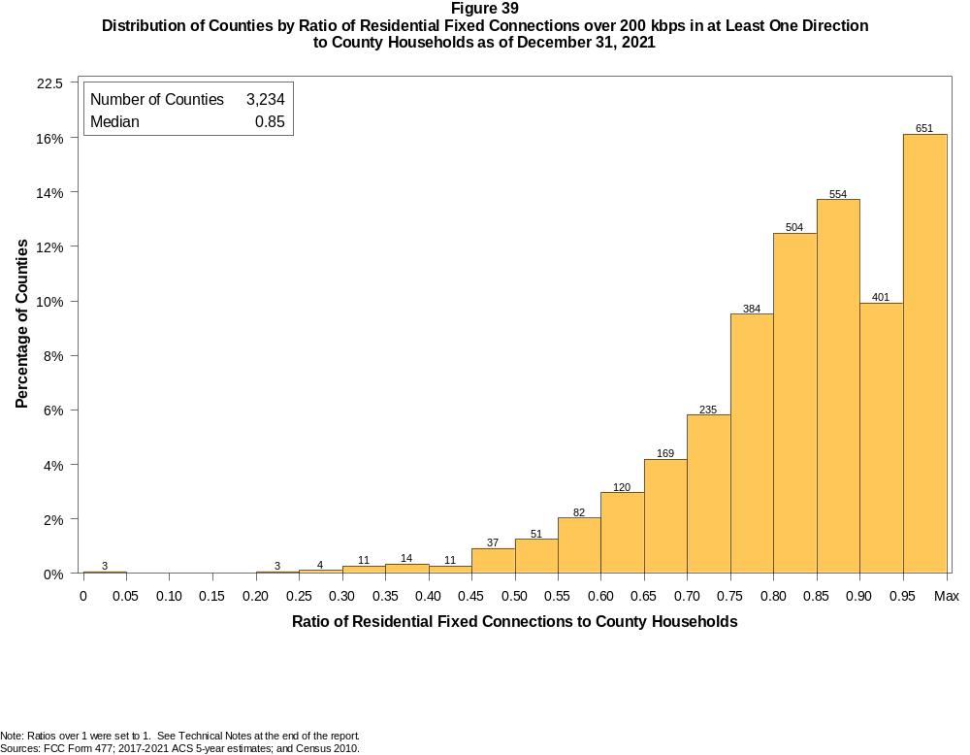

Figure 40
Distribution of Counties by Ratio of Residential Fixed Connections over 200 kbps in at Least One Direction
to County Households by Technology as of December 31, 2021

 | Ratio of Residential Fixed Connections to County Households
Technology | Zero | Greater than 0 and no more than 5% | Greater than 5 and no more than 10% | Greater than 10 and no more than 20% | Greater than 20 and no more than 30% | Greater than 30 and no more than 40% | Greater than 40 and no more than 50% | Greater than 50 and no more than 60% | Greater than 60 and no more than 80% | Greater than 80 and no more than 100% | 100% or more
aDSL | 2.2 | 11.4 | 14.7 | 30.7 | 19.5 | 10.8 | 5.4 | 2.7 | 2.0 | 0.3 | 0.2
sDSL | 96.1 | 3.8 | 0.0 | 0.0 | 0.0 | 0.0 | 0.0 | 0.0 | 0.0 | 0.0 | 0.0
Other Wireline¹ | 93.8 | 6.1 | 0.0 | 0.1 | 0.0 | 0.0 | 0.0 | 0.0 | 0.0 | 0.0 | 0.0
Cable Modem | 11.4 | 5.2 | 4.7 | 10.5 | 12.1 | 11.2 | 11.1 | 11.4 | 17.3 | 4.0 | 1.0
FTTP | 7.4 | 34.8 | 13.4 | 15.6 | 9.3 | 6.1 | 3.9 | 2.9 | 3.8 | 2.4 | 0.4
Satellite | 0.4 | 65.8 | 21.0 | 10.8 | 1.5 | 0.3 | 0.2 | 0.0 | 0.0 | 0.0 | 0.0
Fixed Wireless | 1.8 | 63.4 | 16.2 | 11.3 | 4.1 | 2.0 | 0.5 | 0.4 | 0.2 | 0.0 | 0.1
Total | 0.1 | 0.0 | 0.0 | 0.0 | 0.2 | 0.8 | 1.5 | 4.1 | 28.1 | 54.0 | 11.2

¹ Power Line and Other are summarized with Other Wireline. See Technical Notes at the end of the report for a description of FCC Form 477 technology categories and other reporting requirements.
Note: Numbers may not sum to totals due to rounding.
Sources: FCC Form 477; 2017-2021 ACS 5-year estimates; and Census 2010.

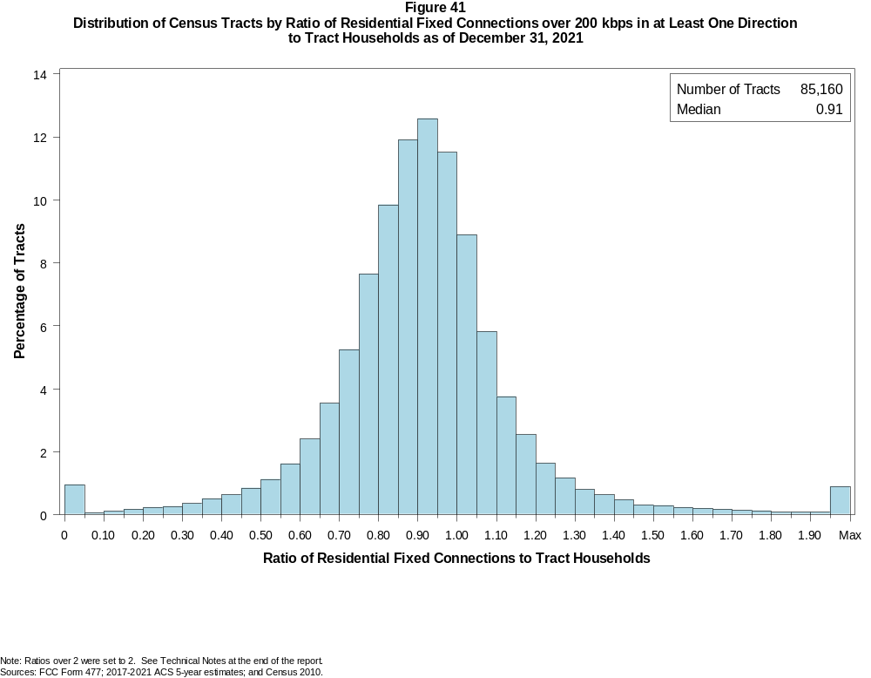

Figure 42
Distribution of Census Tracts by Ratio of Residential Fixed Connections over 200 kbps in at Least One Direction
to Tract Households by Technology as of December 31, 2021

 | Ratio of Residential Fixed Connections to Tract Households
Technology | Zero | Greater than 0 and no more than 5% | Greater than 5 and no more than 10% | Greater than 10 and no more than 20% | Greater than 20 and no more than 30% | Greater than 30 and no more than 40% | Greater than 40 and no more than 50% | Greater than 50 and no more than 60% | Greater than 60 and no more than 80% | Greater than 80 and no more than 100% | 100% or more
aDSL | 9.5 | 27.7 | 16.7 | 24.4 | 12.2 | 4.6 | 2.2 | 1.2 | 1.0 | 0.3 | 0.2
sDSL | 99.7 | 0.3 | 0.0 | 0.0 | 0.0 | 0.0 | 0.0 | 0.0 | 0.0 | 0.0 | 0.0
Other Wireline¹ | 98.9 | 0.8 | 0.1 | 0.1 | 0.1 | 0.0 | 0.0 | 0.0 | 0.0 | 0.0 | 0.0
Cable Modem | 4.9 | 2.4 | 1.4 | 3.0 | 4.2 | 7.0 | 11.3 | 15.0 | 31.7 | 15.0 | 4.2
FTTP | 28.3 | 20.5 | 9.0 | 12.5 | 9.2 | 6.6 | 4.7 | 3.1 | 3.4 | 1.5 | 1.2
Satellite | 31.3 | 58.7 | 5.3 | 3.5 | 0.9 | 0.2 | 0.1 | 0.0 | 0.0 | 0.0 | 0.0
Fixed Wireless | 5.4 | 84.5 | 4.1 | 3.3 | 1.3 | 0.7 | 0.4 | 0.2 | 0.2 | 0.0 | 0.0
Total | 0.9 | 0.0 | 0.1 | 0.3 | 0.5 | 0.9 | 1.5 | 2.7 | 18.9 | 46.0 | 28.2

¹ Power Line and Other are summarized with Other Wireline. See Technical Notes at the end of the report for a description of FCC Form 477 technology categories and other reporting requirements.
Note: Numbers may not sum to totals due to rounding.
Sources: FCC Form 477; 2017-2021 ACS 5-year estimates; and Census 2010.

Figure 43
Percentage of Developed Census Blocks with Residential Fixed Service by Technology as of December 31, 2021
(Internet Access Service over 200 kbps in at least one direction)

 | Number of Providers
Technology | Zero | One | Two | Three | Four | Five | Six | Seven or More
aDSL | 25.3 | 72.9 | 1.7 | 0.0 | 0.0 | 0.0 | 0.0 | 0.0
sDSL | 99.7 | 0.3 | 0.0 | 0.0 | 0.0 | 0.0 | 0.0 | 0.0
Other Wireline¹ | 99.7 | 0.3 | 0.0 | 0.0 | 0.0 | 0.0 | 0.0 | 0.0
Cable Modem | 31.8 | 63.9 | 4.3 | 0.1 | 0.0 | 0.0 | 0.0 | 0.0
FTTP | 64.1 | 32.2 | 3.6 | 0.2 | 0.0 | 0.0 | 0.0 | 0.0
Satellite | 0.0 | 1.2 | 65.1 | 33.7 | 0.0 | 0.0 | 0.0 | 0.0
Fixed Wireless | 21.7 | 32.6 | 23.3 | 13.4 | 6.0 | 2.0 | 0.7 | 0.2
aDSL and/or Cable Modem and/or FTTP | 8.2 | 24.0 | 56.9 | 10.2 | 0.6 | 0.1 | 0.0 | 0.0
Any Technology | 0.0 | 0.0 | 1.8 | 7.5 | 16.9 | 24.8 | 21.6 | 27.4

¹ Power Line and Other are summarized with Other Wireline. See Technical Notes at the end of the report for a description of FCC Form 477 technology categories and other reporting requirements.
Note: Numbers may not sum to totals due to rounding. The number of providers in a census block does not necessarily reflect the number of choices available to a particular household, and does not
purport to measure competition. Providers may list a census block on FCC Form 477 if service can be provided to at least one location in the block. Developed census blocks are those with housing units
based on the 2020 census.
Sources: FCC Form 477 and Census 2020.

Figure 44
Distribution of Counties by Ratio of Residential Fixed Connections to County Households by State as of December 31, 2021
(Connections over 200 kbps in at least one direction)

 |  | Ratio of Residential Fixed Connections over 200 kbps in at Least One Direction to County Households
State | Counties | Zero | Greater than 0 and no more than 5% | Greater than 5 and no more than 10% | Greater than 10 and no more than 20% | Greater than 20 and no more than 30% | Greater than 30 and no more than 40% | Greater than 40 and no more than 50% | Greater than 50 and no more than 60% | Greater than 60 and no more than 80% | Greater than 80 and no more than 100% | 100% or more
Alabama | 67 | 0 | 0 | 0 | 0 | 0 | 0 | 1 | 5 | 30 | 29 | 2
Alaska | 30 | 0 | 0 | 0 | 0 | 1 | 0 | 1 | 3 | 4 | 15 | 6
American Samoa | 5 | 2 | 0 | 0 | 0 | 0 | 0 | 2 | 1 | 0 | 0 | 0
Arizona | 15 | 0 | 0 | 0 | 0 | 0 | 0 | 1 | 0 | 1 | 13 | 0
Arkansas | 75 | 0 | 0 | 0 | 0 | 0 | 0 | 1 | 7 | 40 | 26 | 1
California | 58 | 0 | 0 | 0 | 0 | 0 | 0 | 0 | 0 | 1 | 49 | 8
Colorado | 64 | 0 | 0 | 0 | 0 | 1 | 0 | 0 | 0 | 15 | 27 | 21
Connecticut | 8 | 0 | 0 | 0 | 0 | 0 | 0 | 0 | 0 | 0 | 8 | 0
Delaware | 3 | 0 | 0 | 0 | 0 | 0 | 0 | 0 | 0 | 0 | 1 | 2
District of Columbia | 1 | 0 | 0 | 0 | 0 | 0 | 0 | 0 | 0 | 0 | 1 | 0
Florida | 67 | 0 | 0 | 0 | 0 | 0 | 0 | 0 | 1 | 10 | 29 | 27
Georgia | 159 | 0 | 0 | 0 | 0 | 0 | 2 | 5 | 7 | 59 | 63 | 23
Guam | 1 | 0 | 0 | 0 | 0 | 0 | 0 | 0 | 0 | 0 | 1 | 0
Hawaii | 5 | 0 | 0 | 0 | 0 | 0 | 0 | 0 | 0 | 0 | 1 | 4
Idaho | 44 | 0 | 0 | 0 | 0 | 0 | 0 | 0 | 0 | 11 | 22 | 11
Illinois | 102 | 0 | 0 | 0 | 0 | 0 | 0 | 2 | 8 | 53 | 38 | 1
Indiana | 92 | 0 | 0 | 0 | 0 | 0 | 0 | 1 | 1 | 43 | 46 | 1
Iowa | 99 | 0 | 0 | 0 | 0 | 0 | 0 | 1 | 0 | 31 | 66 | 1
Kansas | 105 | 0 | 0 | 0 | 0 | 1 | 1 | 0 | 2 | 39 | 57 | 5
Kentucky | 120 | 0 | 0 | 0 | 0 | 0 | 0 | 1 | 5 | 36 | 73 | 5
Louisiana | 64 | 0 | 0 | 0 | 0 | 0 | 1 | 1 | 7 | 32 | 22 | 1
Maine | 16 | 0 | 0 | 0 | 0 | 0 | 0 | 0 | 0 | 0 | 7 | 9
Maryland | 24 | 0 | 0 | 0 | 0 | 0 | 0 | 0 | 0 | 4 | 17 | 3
Massachusetts | 14 | 0 | 0 | 0 | 0 | 0 | 0 | 0 | 0 | 0 | 9 | 5
Michigan | 83 | 0 | 0 | 0 | 0 | 0 | 0 | 1 | 1 | 15 | 52 | 14
Minnesota | 87 | 0 | 0 | 0 | 0 | 0 | 0 | 0 | 0 | 8 | 72 | 7
Mississippi | 82 | 0 | 0 | 0 | 0 | 0 | 1 | 3 | 15 | 48 | 14 | 1
Missouri | 115 | 0 | 0 | 0 | 0 | 0 | 0 | 3 | 5 | 44 | 57 | 6
Montana | 56 | 0 | 0 | 0 | 0 | 0 | 0 | 0 | 0 | 8 | 39 | 9
Nebraska | 93 | 0 | 0 | 0 | 0 | 0 | 0 | 1 | 1 | 32 | 56 | 3

Figure 44 - Continued
Distribution of Counties by Ratio of Residential Fixed Connections to County Households by State as of December 31, 2021
(Connections over 200 kbps in at least one direction)

 |  | Ratio of Residential Fixed Connections over 200 kbps in at Least One Direction to County Households
State | Counties | Zero | Greater than 0 and no more than 5% | Greater than 5 and no more than 10% | Greater than 10 and no more than 20% | Greater than 20 and no more than 30% | Greater than 30 and no more than 40% | Greater than 40 and no more than 50% | Greater than 50 and no more than 60% | Greater than 60 and no more than 80% | Greater than 80 and no more than 100% | 100% or more
Nevada | 17 | 0 | 0 | 0 | 0 | 0 | 1 | 1 | 2 | 2 | 10 | 1
New Hampshire | 10 | 0 | 0 | 0 | 0 | 0 | 0 | 0 | 0 | 0 | 5 | 5
New Jersey | 21 | 0 | 0 | 0 | 0 | 0 | 0 | 0 | 0 | 1 | 16 | 4
New Mexico | 33 | 0 | 0 | 0 | 0 | 0 | 0 | 0 | 1 | 8 | 17 | 7
New York | 62 | 0 | 0 | 0 | 0 | 0 | 0 | 0 | 0 | 6 | 45 | 11
North Carolina | 100 | 0 | 0 | 0 | 0 | 0 | 0 | 0 | 1 | 14 | 58 | 27
North Dakota | 53 | 0 | 0 | 0 | 0 | 0 | 0 | 0 | 0 | 4 | 44 | 5
Northern Mariana Isl | 4 | 1 | 0 | 0 | 0 | 0 | 1 | 0 | 1 | 1 | 0 | 0
Ohio | 88 | 0 | 0 | 0 | 0 | 0 | 0 | 1 | 0 | 24 | 61 | 2
Oklahoma | 77 | 0 | 0 | 0 | 0 | 0 | 0 | 3 | 4 | 40 | 30 | 0
Oregon | 36 | 0 | 0 | 0 | 0 | 0 | 0 | 0 | 2 | 6 | 23 | 5
Pennsylvania | 67 | 0 | 0 | 0 | 0 | 0 | 0 | 0 | 0 | 6 | 54 | 7
Puerto Rico | 78 | 0 | 0 | 0 | 0 | 4 | 15 | 13 | 28 | 18 | 0 | 0
Rhode Island | 5 | 0 | 0 | 0 | 0 | 0 | 0 | 0 | 0 | 0 | 3 | 2
South Carolina | 46 | 0 | 0 | 0 | 0 | 0 | 0 | 0 | 1 | 16 | 22 | 7
South Dakota | 66 | 0 | 0 | 0 | 0 | 0 | 1 | 0 | 0 | 9 | 52 | 4
Tennessee | 95 | 0 | 0 | 0 | 0 | 0 | 0 | 0 | 1 | 28 | 60 | 6
Texas | 254 | 0 | 0 | 0 | 0 | 0 | 1 | 0 | 10 | 82 | 126 | 35
Utah | 29 | 0 | 0 | 0 | 0 | 0 | 0 | 0 | 1 | 1 | 14 | 13
Vermont | 14 | 0 | 0 | 0 | 0 | 0 | 0 | 0 | 0 | 0 | 8 | 6
Virgin Islands | 3 | 0 | 0 | 0 | 0 | 0 | 0 | 0 | 0 | 2 | 1 | 0
Virginia | 133 | 0 | 0 | 0 | 0 | 0 | 1 | 4 | 7 | 41 | 69 | 11
Washington | 39 | 0 | 0 | 0 | 0 | 0 | 0 | 0 | 1 | 2 | 26 | 10
West Virginia | 55 | 0 | 0 | 0 | 0 | 0 | 0 | 1 | 3 | 27 | 21 | 3
Wisconsin | 72 | 0 | 0 | 0 | 0 | 0 | 0 | 0 | 0 | 6 | 53 | 13
Wyoming | 23 | 0 | 0 | 0 | 0 | 0 | 0 | 0 | 1 | 0 | 19 | 3
Total | 3,234 | 3 | 0 | 0 | 0 | 7 | 25 | 48 | 133 | 908 | 1747 | 363

Note: Numbers may not sum to totals due to rounding. See Technical Notes at the end of the report.
Sources: FCC Form 477; 2017-2021 ACS 5-year estimates (Households for U.S. and District of Columbia); Census 2010 (Households for Puerto Rico, American Samoa,
Guam, Northern Mariana Islands and U.S. Virgin Islands).

Figure 45
Distribution of Census Tracts by Ratio of Residential Fixed Connections to Tract Households by State as of December 31, 2021
(Connections over 200 kbps in at least one direction)

 |  | Ratio of Residential Fixed Connections over 200 kbps in at Least One Direction to Tract Households
State | Tracts | Zero | Greater than 0 and no more than 5% | Greater than 5 and no more than 10% | Greater than 10 and no more than 20% | Greater than 20 and no more than 30% | Greater than 30 and no more than 40% | Greater than 40 and no more than 50% | Greater than 50 and no more than 60% | Greater than 60 and no more than 80% | Greater than 80 and no more than 100% | 100% or more
Alabama | 1,435 | 5 | 0 | 0 | 0 | 5 | 15 | 41 | 89 | 387 | 616 | 277
Alaska | 177 | 3 | 0 | 0 | 2 | 2 | 4 | 2 | 9 | 31 | 91 | 33
American Samoa | 18 | 2 | 0 | 0 | 0 | 3 | 7 | 2 | 1 | 1 | 1 | 1
Arizona | 1,765 | 30 | 0 | 4 | 13 | 12 | 19 | 20 | 32 | 304 | 697 | 634
Arkansas | 823 | 2 | 0 | 0 | 0 | 2 | 7 | 32 | 78 | 285 | 311 | 106
California | 9,107 | 61 | 4 | 2 | 4 | 9 | 17 | 37 | 79 | 872 | 5,024 | 2,998
Colorado | 1,447 | 17 | 0 | 0 | 1 | 0 | 4 | 5 | 12 | 146 | 723 | 539
Connecticut | 879 | 7 | 0 | 0 | 1 | 0 | 0 | 0 | 3 | 84 | 511 | 273
Delaware | 259 | 3 | 0 | 6 | 5 | 7 | 9 | 6 | 6 | 30 | 61 | 126
District of Columbia | 206 | 2 | 0 | 0 | 0 | 0 | 5 | 3 | 8 | 55 | 73 | 60
Florida | 5,114 | 44 | 2 | 2 | 3 | 5 | 11 | 17 | 77 | 535 | 1,891 | 2,527
Georgia | 2,791 | 10 | 0 | 2 | 1 | 2 | 16 | 34 | 89 | 539 | 1,102 | 996
Guam | 56 | 1 | 0 | 0 | 0 | 1 | 2 | 2 | 1 | 16 | 12 | 21
Hawaii | 436 | 13 | 0 | 0 | 0 | 1 | 1 | 3 | 1 | 46 | 172 | 199
Idaho | 456 | 0 | 0 | 0 | 1 | 2 | 1 | 4 | 7 | 73 | 215 | 153
Illinois | 3,263 | 6 | 0 | 1 | 4 | 3 | 16 | 48 | 93 | 821 | 1,781 | 490
Indiana | 1,693 | 9 | 0 | 0 | 5 | 2 | 13 | 26 | 58 | 440 | 842 | 298
Iowa | 896 | 4 | 0 | 0 | 0 | 0 | 3 | 9 | 14 | 309 | 477 | 80
Kansas | 829 | 14 | 0 | 0 | 1 | 7 | 2 | 1 | 13 | 211 | 431 | 149
Kentucky | 1,306 | 9 | 0 | 1 | 3 | 4 | 7 | 24 | 42 | 313 | 649 | 254
Louisiana | 1,376 | 11 | 1 | 1 | 3 | 9 | 13 | 50 | 96 | 412 | 546 | 234
Maine | 400 | 0 | 0 | 0 | 0 | 0 | 0 | 0 | 0 | 24 | 195 | 181
Maryland | 1,463 | 8 | 1 | 1 | 19 | 29 | 34 | 34 | 35 | 277 | 511 | 514
Massachusetts | 1,613 | 20 | 0 | 2 | 0 | 7 | 16 | 38 | 54 | 264 | 727 | 485
Michigan | 2,971 | 79 | 1 | 0 | 5 | 6 | 24 | 37 | 87 | 587 | 1,535 | 610
Minnesota | 1,502 | 4 | 0 | 0 | 1 | 2 | 2 | 3 | 11 | 278 | 897 | 304
Mississippi | 875 | 4 | 0 | 0 | 2 | 3 | 13 | 39 | 110 | 319 | 262 | 123
Missouri | 1,654 | 4 | 0 | 0 | 4 | 8 | 10 | 46 | 68 | 426 | 772 | 316
Montana | 319 | 2 | 0 | 0 | 0 | 0 | 0 | 2 | 3 | 63 | 168 | 81
Nebraska | 553 | 2 | 0 | 0 | 2 | 0 | 0 | 6 | 10 | 130 | 316 | 87

Figure 45 - Continued
Distribution of Census Tracts by Ratio of Residential Fixed Connections to Tract Households by State as of December 31, 2021
(Connections over 200 kbps in at least one direction)

 |  | Ratio of Residential Fixed Connections over 200 kbps in at Least One Direction to Tract Households
State | Tracts | Zero | Greater than 0 and no more than 5% | Greater than 5 and no more than 10% | Greater than 10 and no more than 20% | Greater than 20 and no more than 30% | Greater than 30 and no more than 40% | Greater than 40 and no more than 50% | Greater than 50 and no more than 60% | Greater than 60 and no more than 80% | Greater than 80 and no more than 100% | 100% or more
Nevada | 775 | 5 | 0 | 0 | 1 | 1 | 3 | 11 | 11 | 104 | 377 | 262
New Hampshire | 349 | 2 | 0 | 0 | 0 | 0 | 0 | 0 | 0 | 12 | 177 | 158
New Jersey | 2,175 | 13 | 2 | 2 | 8 | 19 | 49 | 63 | 105 | 421 | 807 | 686
New Mexico | 612 | 13 | 1 | 2 | 7 | 8 | 6 | 11 | 17 | 148 | 253 | 146
New York | 5,393 | 136 | 0 | 3 | 13 | 29 | 69 | 117 | 179 | 1,262 | 2,200 | 1,385
North Carolina | 2,660 | 19 | 1 | 1 | 0 | 1 | 4 | 7 | 30 | 362 | 1,198 | 1,037
North Dakota | 228 | 0 | 0 | 0 | 0 | 0 | 0 | 0 | 1 | 53 | 131 | 43
Northern Mariana Isl | 23 | 2 | 1 | 0 | 0 | 0 | 2 | 3 | 5 | 7 | 2 | 1
Ohio | 3,162 | 12 | 0 | 0 | 1 | 6 | 8 | 19 | 52 | 592 | 1,907 | 565
Oklahoma | 1,205 | 11 | 1 | 0 | 1 | 10 | 20 | 30 | 70 | 387 | 476 | 199
Oregon | 994 | 2 | 0 | 0 | 1 | 1 | 1 | 7 | 11 | 124 | 555 | 292
Pennsylvania | 3,445 | 48 | 1 | 0 | 2 | 7 | 23 | 51 | 88 | 797 | 1,677 | 751
Puerto Rico | 939 | 19 | 2 | 20 | 103 | 162 | 155 | 153 | 95 | 88 | 42 | 100
Rhode Island | 247 | 1 | 0 | 0 | 0 | 0 | 5 | 6 | 1 | 46 | 103 | 85
South Carolina | 1,317 | 11 | 0 | 1 | 0 | 0 | 3 | 9 | 50 | 286 | 508 | 449
South Dakota | 242 | 0 | 0 | 0 | 1 | 0 | 0 | 0 | 2 | 51 | 150 | 38
Tennessee | 1,701 | 23 | 0 | 0 | 0 | 2 | 9 | 19 | 47 | 395 | 811 | 395
Texas | 6,883 | 54 | 3 | 0 | 2 | 7 | 30 | 78 | 213 | 1,480 | 2,840 | 2,176
Utah | 716 | 7 | 2 | 1 | 4 | 2 | 2 | 8 | 8 | 84 | 325 | 273
Vermont | 193 | 1 | 0 | 0 | 0 | 0 | 0 | 1 | 1 | 4 | 109 | 77
Virgin Islands | 29 | 0 | 0 | 0 | 0 | 0 | 2 | 4 | 2 | 14 | 6 | 1
Virginia | 2,186 | 26 | 7 | 4 | 24 | 31 | 63 | 88 | 110 | 414 | 738 | 681
Washington | 1,772 | 3 | 2 | 0 | 0 | 3 | 5 | 4 | 7 | 119 | 963 | 666
West Virginia | 546 | 1 | 0 | 0 | 0 | 0 | 8 | 13 | 34 | 214 | 224 | 52
Wisconsin | 1,526 | 3 | 1 | 0 | 0 | 2 | 5 | 3 | 13 | 300 | 881 | 318
Wyoming | 160 | 1 | 0 | 1 | 0 | 0 | 0 | 1 | 2 | 22 | 94 | 39
Total | 85,160 | 789 | 33 | 57 | 248 | 422 | 743 | 1,277 | 2,340 | 16,064 | 39,163 | 24,024

Note: Numbers may not sum to totals due to rounding. See Technical Notes at the end of the report.
Sources: FCC Form 477; 2017-2021 ACS 5-year estimates (Households for U.S. and District of Columbia); Census 2010 (Households for Puerto Rico, American Samoa,
Guam, Northern Mariana Islands and U.S. Virgin Islands).

